**Contents**

Author’s Note 7

WORKING SCIENTIFICALLY SKILLS 8

Experimental Design 8

Rearranging Equations 9

Module 5: Advanced Mechanics 11

Constants 11

Equations 11

Motion Equations 13

Vectors and Vector Decomposition 14

Projectile Motion 15

1D Vertical Motion 15

1D Horizontal Motion 15

Rotational Motion 16

Converting Degrees to Radians to Degrees 16

RPM to Radians per Second 16

Velocity due to Rotation 16

Torque 17

Torque Equilibrium Questions 17

Circular Motion 18

Work and Energy in Circular Orbits 18

Tension as Centripetal Force 19

Banked Curves 19

Friction around a Corner 20

Motion in Gravitational Fields 21

Gravitational Force 21

Circular Motion in a Gravitational Field 21

Reminder about Work 21

Reminder about Potential Energy 22

Work in a Gravitational Field 22

Calculating Work done by Gravity 23

Escape Velocity 23

Total Energy of an Orbit 24

Kepler’s Laws 26

1st Law 26

2nd Law 26

3rd Law 26

Formula Derivations 27

Kepler’s Third Law 27

Escape Velocity 27

Velocity of a Satellite 27

Advanced Mechanics Questions 29

Question 1 29

Algebraic Answers 30

Numerical Answers 31

Question 2 32

Answer 2 32

Question 3 33

Answer 3 33

Question 4 34

Answer 4 34

Question 5 34

Answer 5 35

Question 6 36

Answer 6 36

Module 6: Electromagnetism 38

Base Units 38

Constants 38

Equations 38

Electrostatics 38

Circuits 39

Magnetism 40

Electromagnetism 41

Transformers 41

Course Notes 42

Charges Moving in an Electric Field 42

Voltage 42

The Magnetic Field 42

Charges Moving in a Magnetic Field 42

Flux 43

Induction 43

The Right Hand Rule(s) 46

The Motor Effect 47

Force on Parallel Conducting Wires 47

Motors 48

Generators 50

Transformers 52

Electromagnetism Questions 55

Question 1 55

Answer 1 55

Question 2 57

Answer 2 57

Question 3 57

Answer 3 58

Question 4 58

Answer 4 58

Question 5 59

Answer 5 59

Question 6 60

Answer 6 60

Question 7 61

Answer 7 61

Module 7 – The Nature of Light 62

Constants 62

Equations 62

Course Notes 63

Attempts to Measure the Speed of Light 63

Waves need a medium – so what about light? 67

Maxwell 71

Diffraction 72

The Quantum Nature of Light 75

Polarisation 78

Light has Momentum? 80

Model of Light Questions 81

Question 1 81

Answer 1 81

Question 2 82

Answer 2 82

Question 3 82

Answer 3 82

Question 4 83

Answer 4 83

Question 5 83

Answer 5 83

Module 7 – The Nature of Light: Special Relativity 84

Base Units 84

Constants 84

Equations 84

Galilean / Newtonian Relativity 84

Special Relativity 84

Course Notes 86

Inertial Reference Frames 86

Non-Inertial Reference Frames 86

Einstein’s Postulates 87

Events in Relativity 87

The Lorentz Factor 87

Two things to remember 87

An Introduction to Special Relativity 88

Length Contraction – An Explanation from the Experts 89

Time Dilation 90

Length Contraction 92

The Momentum Equation and the Universal Speed Limit 93

The Ladder Paradox 94

The Twins Paradox 95

Experimental Verification for Special Relativity 96

Special Relativity Questions 97

Question 1 97

Answer 1 97

Question 2 98

Answer 2 98

Module 8 – From the Universe to the Atom 99

Base Units 99

Constants 99

Equations 99

Course Notes 101

Models of The Atom 101

Emission Spectrum of Hydrogen and the Balmer Series 106

The Standard Model 107

Nuclear Physics 113

The Big Bang and the Origins of the Elements 123

The formula not on the sheet 128

From the Universe to the Atom Questions 129

Question 1 129

Answer 1 129

Question 2 130

Answer 2 130

Question 3 131

Answer 3 131

Question 4 132

Answer 4 132

Question 5 133

Answer 5 133

Question 6 134

Answer 6 134

Question 7 135

Answer 7 135

Smarter Study 136

Top Tips 136

Link Concepts to Formulae 136

Understand the Maths 136

Exam Tips 136

Maths Questions: Do the algebra 137

Maths Questions: You don’t have to simplify 137

Written Questions: Dot points 138

Written Questions: Everything is a process 138

Most Tested Concepts 139

Advanced Mechanics 139

Electromagnetism 139

The Nature of Light 139

From the Universe to the Atom 140

Common Questions 140

# Author’s Note

First of all, I should probably start by doing what everyone does and say *good luck*. I hope that you won’t need it, but a little luck never hurts.

You may have noticed that physics has this aura of being the subject that people take because it “has good scaling”, which sometimes means that people take physics without ever learning to appreciate what it is trying to teach.  
Physics isn’t meant to be rote learned, you aren’t meant to memorise every single type of question you might see, you’re meant to **understand**. And once you understand it, you can learn to see the physics of your everyday life, and that’s when you can really enjoy physics.

So then I guess the goal of this book is that, by the end, you understand the physics. Further than that, my hope is that you will have an appreciation for *why* these things occur and are equipped with the skills to not only answer questions in an exam but also the ability to explain the world around you with physics.

# WORKING SCIENTIFICALLY SKILLS

This is the most vague part of the syllabus but the general idea is that you are meant to learn these skills throughout the entire course, particularly as part of the compulsory lab component.

The skills you are meant to have, at least in theory, are as follows

* You should be able to determine the appropriate variables (i.e. control, independent, dependent) for an experiment.
* You should be able to rearrange an equation to properly analyse the results of an experiment (**more on this in a bit**).
* You should be able to assess the risks of an experiment and determine whether it is safe to do
* You should be able to consider the *ethical issues* surrounding an experiment (yeah there aren’t many of those here thank goodness)

You might think that the best thing to do is just gather as much data as possible and to do the calculations later. But it’s better to sit and think about it for a bit. In the case of class experiments it might only be for a minute, for depth studies it might be a few days. But take the time to actually think about what you’re doing and how you can make sure you get good results.

It sounds annoying, but it’s definitely worth it to get better results in the end.

## Experimental Design

Ok, picture this: your experiment is dropping a ball, measuring its displacement using a camera, and trying to determine acceleration due to gravity.

Well, first of all you have to make sure you can actually measure its displacement accurately. You have to remember that a camera uses pixels, so you have to ‘calibrate’ it which means you have to put a ruler in the image so that the camera knows how many metres a pixel is (there are many pieces of software such as Tracker that can help do this for you).

But you also have to remember that things look smaller when they’re far away, so the ruler in the frame needs to be close to where you’re dropping the ball from.

Then you need to decide what ball you use, since something like a Styrofoam ball isn’t heavy enough and is affected too much by air resistance, but a heavy steel ball will crush your feet (remember safety).

There are lots of things to think about when designing an experiment and it is the ability to think of these things and to design an experiment around it which is what this section of the syllabus is about.

## Rearranging Equations

Ok so let’s go back to the experiment from before. You are dropping a ball, recording its displacement over time with a camera. The camera takes pictures 60 times a second (at 60 Hz) and therefore you know the time between each frame and therefore the position at a certain time. Your goal is to measure gravitational acceleration.

Ok so after you get your results, you put them in Excel and get this:

Yeah, not very straight.

But if you look at the equation:

$$s=ut+\frac{1}{2}at^{2}$$

In this case the initial velocity is 0 and acceleration is $g$ so we just get

$$s=\frac{1}{2}gt^{2}$$

$$\frac{s}{t^{2}}=\frac{g}{2}$$

This means that a graph of displacement as a function of time squared should have a gradient of $g/2$. So, we just graph $s$ on the $y$ axis and $t^{2}$ on the $x$ axis:

From the graph we can now see that the gradient is $4.8838 m s^{-2}$, meaning our value for $g$ is $9.7676 m s^{-2}$. Not too bad at all.

But remember, we were only able to get a straight line because we understood and properly rearranged the equation. This is where most of the harder thinking comes in when designing an experiment.

# Module 5: Advanced Mechanics

**Definition**: Mechanics combines kinematics (the study of motion) and dynamics (the study of forces) and combines them into Mechanics – the study of how forces affect the motion of physical objects.

## Constants

Gravitational Constant: $G=6.67×{10}^{-11}$ ($N m^{2} kg^{-2}$)  
Mass of the Earth: $m_{E}=6.0×{10}^{24}$ ($kg$)  
Radius of the Earth: $r_{E}=6.371×{10}^{6}$ ($m$)

## Equations

$${\overset{⃑}{F}}_{net}=m\overset{⃑}{a}$$

Newtons is a measure of Force; One Newton is equivalent to one: kilogram metres-per-second-per-second (kg ms-2). The net means sum of all forces which accounts for the fact that there can be forces on an object but if they cancel there is no acceleration.

$$W=\overset{⃑}{F}⋅\overset{⃑}{s}=Fs\cos{θ}=ΔE_{K}$$

$ΔE_{K}=\frac{1}{2}mv^{2}-\frac{1}{2}mu^{2}$

Work is the component of the Force parallel to the path travelled. It is also the change in kinetic energy over that path.

$$F_{c}=\frac{mv^{2}}{r}$$

$$a_{c}=\frac{v^{2}}{r}$$

Centripetal force or acceleration on an object derived from circular motion. Centripetal force is the description of the sum of forces on an object in circular motion. The actual force is often generated by tension in a string or a gravitational field.

$$θ=\frac{l}{r}$$

$$ω=\frac{∆θ}{Δt}=\frac{v_{⊥}}{r}$$

Angular equivalents of linear factors. Equations for angular displacement and angular velocity for an object spinning in a circle. Measured in **radians** or **radians** per second.

$$\left|\overset{⃑}{τ}\right|=\left|\overset{⃑}{r}×\overset{⃑}{F}\right|=r_{⊥}F=rF\sin{θ}$$

Torque on a rotating object is the Force on that object multiplied by the radius from the axis of rotation multiplied by sine of the angle between them (or it is also valid to say radius from the axis multiplied by the force perpendicular to that radius).

$$F_{G}=G\frac{m_{1}m_{2}}{r^{2}}$$

$$a_{G}=G\frac{m_{1}}{r^{2}}$$

Gravitational Force between two objects of mass at some radius. $G$ is the gravitational constant.

The acceleration due to gravity is dependent on the mass of the object generating the field.

$$v=\frac{2πr}{T}$$

Kepler’s second law of planetary motion. It states the average speed of a planet in motion is proportional to its average orbital radius divided by the time for one orbit around the sun.

$$\frac{r^{3}}{T^{2}}=\frac{GM}{4π^{2}}$$

Kepler’s third law of planetary motion. The relationship between radius and period of orbit with a constant (where M is the mass of the object it orbits).

$$v_{esc}=\sqrt{\frac{2GM}{r}}$$

Escape velocity of an object with mass at an initial distance, $r$, away. It is the minimum velocity an object must have to escape the gravity of that object.

$$U_{G}=-\frac{Gm_{1}m_{2}}{r}$$

The potential energy due to gravity of an object in another objects gravitational field. Note that it is not necessarily the total potential energy, but often is (there can be electric potential).

### Motion Equations

$$\overset{⃑}{s}=Δpos={pos}_{f}-{pos}_{i}$$

The displacement of an object is the change in its position (final – initial). For example, if an object begins on a cliff $5 m$ off the ground and finishes on the ground, its displacement is ${\overset{⃑}{s}}_{y}=-5 m$

$$\overset{⃑}{s}=\frac{\overset{⃑}{a}}{2}t^{2}+\overset{⃑}{u} t$$

The displacement of an object in a given direction is given by this equation, where the displacement, acceleration and initial velocity are all vector components in the same direction. i.e. If the displacement is the displacement in the $x$ direction, then the acceleration is the acceleration in the $x$ direction. It is possible for this to be zero.

*Note that it is a quadratic in terms of $t$.*

The velocity of an object is given by the acceleration in that direction and the initial velocity in that direction.

$$\overset{⃑}{v}=\overset{⃑}{a}t+\overset{⃑}{u}$$

$$v^{2}=u^{2}+2as$$

A rearrangement of the above formulae. Useful when time is not given.

# Vectors and Vector Decomposition

When you are given a vector, it normally has some angle from an axis (e.g. velocity of $5 ms^{-1}$ $30° above the horizontal$). This might look something like:

$$θ=30°$$

$$v=5 ms^{-1}$$

Now we need to invent a coordinate system. Since we are given the angle of the vector from the horizontal (meaning perpendicular to gravity) we shall let the ‘horizontal’ be our $x$ axis and the vertical be our $y$ axis.

$$x$$

$$y$$

Now we can draw our vector as:

$$x$$

$$y$$

$$θ=30°$$

$$v=5 ms^{-1}$$

$$v_{y}$$

$$v_{x}$$

Using trigonometry, we can find that:

$$v_{x}=v\cos{θ}≈4.3 ms^{-1}$$

$$v_{y}=v\sin{θ}=2.5 ms^{-1}$$

If this problem were on a slope, then instead you would setup your axes like this:

$$x$$

$$y$$

## Projectile Motion

Projectile motion isn’t really one of the difficult areas of study, but it is one of the places where you are almost guaranteed to make a stupid mistake.

When you’re solving projectile motion questions you need to be *really* careful that you’re thinking about the positions, velocities and accelerations *in one dimension*. If you are solving for the $x$ displacement but you substitute in $a=-9.8 m s^{-2}$ (which is the $y$ acceleration) then you’re… an idiot.

### 1D Vertical Motion

In vertical projectile motion an object is thrown or projected upwards with some initial velocity $u$ and it has some downward acceleration on it $g$.

In this case we just use the equations from standard projectile motion, with $a_{y}=-g$  
:

$$s_{y}=\frac{1}{2}\left(-g\right)t^{2}+u_{y}t$$

$$v_{y}=-gt+u_{y}$$

$$v_{y}^{2}=u_{y}^{2}-2gs_{y}$$

### 1D Horizontal Motion

In this case, you have to remember that horizontally gravity does not do anything, so there is no acceleration due to gravity. This means we have $a_{x}=0$:

$$s_{x}=0+u_{x}t$$

$$v_{x}=0+u$$

**If** you get a question which has some form of friction acting at the base, then there is acceleration due to the friction.

## Rotational Motion

### Converting Degrees to Radians to Degrees

In one rotation there are 360° or 2 $π$ radians. Therefore:

* To convert degrees to radians, multiply by $\frac{π}{180}$
* To convert radians to degrees, multiply by $\frac{180}{π}$

### RPM to Radians per Second

To convert RPM to Radians per second, first convert it to Revs per second by dividing it by 60 (i.e. 60rpm will be 1 rotation per second). Then since one revolution is $2π$ radians, multiply the Revs per second by $2π$.

### Velocity due to Rotation

The velocity due to the rotational motion of an object, at some radius $r$, is given by

$$v_{r}=rω$$

(remember that $ω$ is in $rad s^{-1}$)

### Torque

A torque $\left(τ\right)$ is generated when a force acts at a distance from the axis of rotation. As an example take this situation:

$$r$$

$$F$$

$$θ$$

The torque generated here is $τ=rF\sin{θ} (anticlockwise)$.

### Torque Equilibrium Questions

$$50 cm$$

$$0 cm$$

$$40 cm$$

$$100 cm$$

$$25 N$$

$$x N$$

$$30 N$$

The torque questions like what is pictured above rely on the idea that $∑τ=0$. This means the torques on the left of the pivot are equal to the torques on the right.  
These questions can also be tricky in that the centre is defined as $50cm$, which means the force at $0cm$ is actually at a radius of $50cm$ etc.

## Circular Motion

When there is an acceleration which is perpendicular to the velocity of an object, it acts to rotate that velocity. However, so long as it is perpendicular, it will never change the magnitude of the velocity,

$$\overset{⃑}{v}$$

$$\overset{⃑}{a}$$

$$⟹$$

$$\overset{⃑}{v}$$

$$\overset{⃑}{a}$$

But in circular motion, the acceleration is always perpendicular to the velocity, so the velocity never changes magnitude and always changes direction.  
Though it’s way too complicated to show here, it is possible to prove from this alone that the net acceleration $a_{c}$ which is causing this motion is given by

$$\overset{⃑}{v}$$

$$\overset{⃑}{r}$$

$$\overset{⃑}{a}$$

$$a_{c}=\frac{v^{2}}{r}$$

Notice that the acceleration is parallel but opposite to the radius vector. This is also one of the major features of circular motion. Since the acceleration has to ‘pull’ the velocity around, it must always be pointing inwards.

### Work and Energy in Circular Orbits

One thing you might remember from Year 11 Dynamics is that work (force over a distance) causes a change in kinetic energy. The ‘over’ part of that definition is characterised by the $\cos{θ}$ term in the equation $W=Fs\cos{θ}$. When the force is perpendicular to the path the angle term is $90°$ so $W=0$. This means that the force causing centripetal acceleration does not increase or decrease the speed (which is important since $a_{c}={v^{2}}/r$).

However, an extra force parallel to the path can cause the energy to increase.

### Image result for centripetal force tension questionTension as Centripetal Force

In this example of circular motion, the vertical component of tension is the force opposing gravity and the horizontal is the centripetal force.

The interesting implication of this is that when you swing an object on a string in real life, it can never be perfectly flat, there will always be a slight angle between the string and the vertical because the force needs to oppose gravity.

### Banked Curves

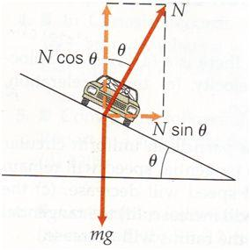In a typical banked curve question the centripetal force is considered to be the inward component of the normal force and the vertical component of the normal force is the opposite of gravity.

### Friction around a Corner

Going around a flat corner, the static friction acts as the centripetal force. When you’re driving you may know that you need to accelerate into a curve to keep your speed. This is due to other forces like rolling resistance, not the static friction which actually allows you to turn, so you don’t need to worry about that in these problems. Since static friction is always given by $f_{s}≤μ_{s}N$ and $F_{c}=f_{s}$, we can say:

$$\frac{mv^{2}}{r}≤μ_{s}N$$

Kinetic friction does not typically act as the centripetal force since it requires a rather strange setup to work, however if it is acting as the centripetal force, we know that $f_{k}=μ_{k}N$ so:

$$\frac{mv^{2}}{r}=μ_{k}N$$

## Motion in Gravitational Fields

### Gravitational Force

The force due to gravity by an object with mass $m_{1}$ always points towards the centre of mass of that object and causes a force on an object with mass $m_{2}$ of

$$F_{g}=-G\frac{m_{1}m_{2}}{r^{2}}$$

The negative represents that the force is attractive and $r$ is the distance between the centres of mass of $m_{1}$ and $m_{2}$.

Using $F=ma$ we also know that the acceleration due to $m_{1}$’s gravity is

$$a_{g}=-G\frac{m_{1}}{r^{2}}$$

It’s worth mentioning that this equation is true for any object at large distances and always true for spheres, even at the surface (but not inside).

### Circular Motion in a Gravitational Field

So, as I mentioned, gravitational force always points towards the centre of the object causing it. And circular motion needs a force which is always pointed towards the centre of a circle. The perfect couple!

Yep, that’s basically why things orbit gravitational objects, it kinda just works.

Anyway, for an object to orbit in a gravitational field, the force due to gravity needs to be equal to the centripetal force. **Remember** that the numbers matter, if the gravity is acting on $m_{2}$ then the equation is:

$$\frac{m_{2}v^{2}}{r}=G\frac{m_{1}m_{2}}{r^{2}}$$

### Reminder about Work

Ok, so think back to Yr 11 Physics where you learnt about work $\left(W\right)$. You might remember that work is a force over a distance $\left(W=Fs\cos{θ}\right)$ however what you might not remember is that work is also the change in kinetic energy $\left(W=ΔE_{K}=\frac{1}{2}mv^{2}-\frac{1}{2}mu^{2}\right)$.

**But** this only works if the force is constant along that distance, if it isn’t then we need something else.

### Reminder about Potential Energy

Along with work, you might also remember that there's this thing called potential energy $(U)$.

Wherever there is a force field (e.g. the gravitational field) there is an associated potential energy .It is worth remembering that there isn't a potential energy for forces like friction, just fields like gravity (if you study further physics you'll learn how it's also true for the electrostatic field).

Now, it might seem really weird, but believe it or not potential energy was invented as a sort of band-aid so that conservation of energy works. It obeys the simple rule that the total change in kinetic and potential energy is always zero, so if your kinetic energy increases by some amount $E$, then your potential energy must decrease by that amount.

$$Δ\left(E_{K}+U\right)=0$$

From this we can show that

$$ΔE_{K}=-ΔU$$

In the case of a gravitational field it is also true that $W=-ΔU$

### Work in a Gravitational Field

Ok, we've gotten through the really abstract stuff, so now it's onto how this works for gravity. The derivation for the gravitational potential energy equation is a little outside the scope of the physics course, so in no way do you need to know it, but it has been included for those who are curious. The derivation basically says that if an object started out at almost infinity and was pulled in to some distance $r$ by gravity, how much work was done? Then, since the initial potential energy is zero, the change in potential energy is just the potential energy at $r$.

$$U=-W_{∞→r}$$

$$U=-\int_{∞}^{r}{-\frac{Gm_{1}m_{2}}{r^{2}}\hat{r}⋅d\overset{⃑}{r}}$$

$$=-Gm_{1}m_{2}\int_{r}^{∞}{r^{-2} dr}$$

$$=-Gm_{1}m_{2}{\left[\frac{1}{r}\right]}_{∞}^{r}$$

$$U_{g}=-\frac{Gm_{1}m_{2}}{r}$$

This is the equation on the formula sheet and is the absolute potential energy at a given radius $r$.

### Calculating Work done by Gravity

If an object such as a rocket with mass $m$ falls from a distance $d$ to the Earth's surface ($r_{E}$) – *yep sometimes life it just like that* - then the change in gravitational potential is

$$ΔU_{g}={U_{g}}_{f}-{U_{g}}_{i}$$

$$=\left(-\frac{Gm_{1}m_{2}}{r_{f}}\right)-\left(-\frac{Gm_{1}m_{2}}{r_{i}}\right)$$

$$=-GM_{E}m\left(\frac{1}{r_{E}}-\frac{1}{d}\right)$$

We also know that the change in gravitational potential energy is also the negative of the work done ($W=-ΔU_{g}$).

$$W=-\left(-GM_{E}m\left(\frac{1}{r_{E}}-\frac{1}{d}\right)\right)$$

$$=GM_{E}m\left(\frac{1}{r_{E}}-\frac{1}{d}\right)$$

$$W=ΔE_{K}$$

It is important to distinguish that this is the contribution by gravity to the work done. For instance, if the rocket was trying to slow its fall by firing its engines then there would be a negative work done by the engines (negative since the force is reducing the kinetic energy as it falls). This would make the total work done lower and potentially even negative, meaning even though Earth was pulling the rocket down, it still slowed down as it fell.

### Escape Velocity

As an object moves away from large a gravitational source such as a planet, the gravity of that planet tries to pull the object back.

Ok cool, but we also know how to describe that as a work being done and, therefore, a change in potential energy. We know that potential energy increases as you get further away (like how lifting a ball off the ground increases its potential energy) so we know that there must be negative work being done by gravity as it moves away (i.e. it's slowing it down).

Escape velocity is the speed at which you have to launch something so that the gravity of the other object will cause it to have 0 kinetic energy as the object gets infinitely far away. Yep, wow that's a lot to take in, but sadly there really isn't a much simpler way of putting it.

Let's write this out mathematically.

First we simply start by saying that the work done is equal to the change in kinetic energy from the initial position $r$ to $∞$.

$$W_{g}=ΔE_{K}$$

$$={E_{K}}_{f}-{E_{K}}_{i}$$

Final velocity is 0 so:

$$W_{g}=-{E_{K}}_{i}$$

Now we substitute that $W_{g}=-ΔU_{g}$:

$$ΔU_{g}=E_{K}$$

Defining the change in potential energy as from $r$ to $∞$ lets us say that the final kinetic energy as the object gets infinitely far away will be 0, but the potential energy there is also 0, making the total energy 0.

Therefore, since energy must be conserved, we can say:

$$U+E_{K}=0$$

$$\frac{1}{2}m_{2}v^{2}=-\left(-\frac{Gm_{1}m_{2}}{r}\right)$$

$$\frac{1}{2}m_{2}v^{2}=\frac{Gm_{1}m_{2}}{r}$$

$$v_{esc}=\sqrt{\frac{2Gm_{1}}{r}}$$

And this is the escape velocity of an object.

### Total Energy of an Orbit

If an object of mass $m$ orbits gravitationally at a distance $r$ from a planet with mass $M$ then it has potential energy:

$$U_{g}=-\frac{GMm}{r}$$

If it is in a circular orbit with speed $v$ then we also know that the gravitational force is acting as the centripetal force i.e.

$$\frac{mv^{2}}{r}=\frac{GMm}{r^{2}}$$

It is now possible to derive its kinetic energy:

$$\frac{GMm}{r^{2}}=\frac{mv^{2}}{r}$$

$$\frac{GMm}{r}=mv^{2}$$

$$\frac{GMm}{2r}=\frac{1}{2}mv^{2}$$

$$-\frac{1}{2}U_{g}=E_{K}$$

From this, the total energy ($E_{K}+U_{g}$) is given by:

$$E_{K}+U=\frac{GMm}{2r}-\frac{GMm}{r}$$

$$E_{T}=-\frac{GMm}{2r}$$

## Kepler’s Laws

### 1st Law

Planets orbit in ellipses with the Sun at one of the foci.

### 2nd Law

The imaginary line connecting the planet and the sun sweeps out the same area per unit time no matter how fast it is going or where it is.

### 3rd Law

$$\frac{GM}{4π^{2}}=\frac{r^{3}}{T^{2}}$$

Where $r$ is the orbital radius, $T$ is the time for one orbit and $M$ is the mass of the object causing the orbit.

## Formula Derivations

### Kepler’s Third Law

*Q.E.D.*

$$F_{G}=F_{c}$$

$$G\frac{m_{1}m_{2}}{r^{2}}=\frac{m_{2}v^{2}}{r}$$

$$\frac{Gm_{1}}{r}=v^{2}$$

$$v=\frac{2πr}{T}$$

$$\frac{Gm_{1}}{r}=\frac{4π^{2}r^{2}}{T^{2}}$$

$$\frac{Gm_{1}}{r^{3}}=\frac{4π^{2}}{T^{2}}$$

$$\frac{Gm_{1}}{4π^{2}}=\frac{r^{3}}{T^{2}}$$

### Escape Velocity

*Q.E.D.*

$$E_{K}={-U}_{G}$$

$$\frac{1}{2}mv^{2}=G\frac{Mm}{r}$$

$$v^{2}=\frac{2GM}{r}$$

$$v_{esc}=\sqrt{\frac{2GM}{r}}$$

### Velocity of a Satellite

*Q.E.D.*

$$F_{c}=F_{G}$$

$$\frac{mv^{2}}{r}=G\frac{Mm}{r^{2}} ⇒ v^{2}=\frac{GM}{r} ⇒ v=\sqrt{\frac{GM}{r}}$$

#### Total Energy of an orbiting Object

$$E_{net}=E_{k}+U_{G}$$

$$=\frac{1}{2}mv^{2}-\frac{GMm}{r}$$

$$\frac{GMm}{r^{2}}=\frac{mv^{2}}{r}$$

$$\frac{GM}{r}=v^{2}$$

*Q.E.D.*

$$E_{net}=\frac{1}{2}m\left(\frac{GM}{r}\right)-\frac{GMm}{r}$$

$$=\frac{1}{2}\frac{GMm}{r}-\frac{GMm}{r}$$

$$=-\frac{GMm}{2r}$$

## Advanced Mechanics Questions

### Question 1

So, here’s a pretty complex example which we’re going to work through slowly and really show what the thought process is when solving these problems. This will have a lot more working than the other answers but it serves as a good example of the type of working you should be doing for all questions.

$$θ$$

$$u$$

$$h_{R}$$

$$h_{T}$$

$$s_{x}$$

A ball is rolled up a slope off a table with initial velocity $v$ at angle $θ$ from the vertical.

1. How long does it take the ball to hit the ground?
2. How far is it from the edge of the table when it hits the ground?
3. What is the ball’s velocity when it hits the ground?
4. What is the ball’s displacement from the edge of the table when it is at the highest point of its arc? (Extension Question)

Solve the above problems if:

$$u=15ms^{-1} \\ θ=30° \\ h_{T}=1.2m \\ h_{R}=0.24m$$

### Algebraic Answers

1. To solve this first question, we need to construct an equation that solves for when the height of the ball is the height of the floor, which we are going to define as when $s_{y}=0$. We are also going to define up as positive.

On the formula sheet, the equation for displacement is $s=ut+\frac{1}{2}at^{2}$. Although this formula is good, it has an issue. When $t=0$, displacement is also zero ($s=0$) but at $t=0$ the height of the ball is $h_{T}+h_{R}$ which means our equation is slightly wrong. We can fix this by using the equation detailed above in the notes: $y_{f}-y_{i}=\frac{a_{y}}{2}t^{2}+u_{y}t$ where $y_{i}=h_{T}+h_{R}$.

We want to solve for when the final position is the ground (0).

Now we have a displacement equation in the y-direction, we need to find the initial velocity and acceleration in the y-direction. Using trig rules, $u_{y}=u\sin{θ}$. Acceleration is just gravity which can be defined as $g=-9.8$ ( $-$ because up is $+$).

Now to find $t$, we need to use the quadratic formula:

$$t=\frac{-u_{y}±\sqrt{{\left(u_{y}\right)}^{2}-4\left(\frac{g}{2}\right)\left(y_{i}\right)}}{2\left(\frac{g}{2}\right)}$$

1. To find the horizontal distance from the table ( $s_{x}$ in the diagram) we take the time taken to hit the ground and multiply it by the initial horizontal velocity. This can be derived from the displacement formula $x_{f}-x_{i}=\frac{a_{x}}{2}t^{2}+u_{x}t$ where $a_{x}=0, x_{i}=0$. $$∴s_{x}=u_{x}t$$

$u_{x}$ is given by the horizontal component of the initial velocity, i.e. $u_{x}=u\cos{θ}$

1. To find the final velocity, we have to add the two velocity vectors at the time of the collision with the ground. We already found $t$ in a) and we know the horizontal velocity is constant throughout the flight, therefore the only new fact we need is the final vertical velocity.

$$ϕ$$

$${\overset{⃑}{v}}_{x}$$

$${\overset{⃑}{v}}_{y}$$

$${\overset{⃑}{v}}_{f}$$

$v_{y}=gt+u_{y}$ gives the final velocity after some time and we use this to find the downward velocity at the time of collision.  
Now for vector addition:

$$|{\overset{⃑}{v}}_{f}|=\sqrt{{{\overset{⃑}{v}}_{x}}^{2}+{{\overset{⃑}{v}}_{y}}^{2}}$$

$$ϕ=\tan^{-1}\left(\frac{{\overset{⃑}{v}}_{y}}{{\overset{⃑}{v}}_{x}}\right)$$

1. (Extension) To solve this question, we have to find where the vertical velocity is zero as this is when the ball has risen to its peak. Because we want the height above  
   To find this we set $v_{y}=0=gt+u_{y}$ and solve for time at the peak:

$$t_{p}=-\frac{u_{y}}{g}$$

Now we plug this time into our displacement equations:

$${\overset{⃑}{s}}_{x}={\overset{⃑}{v}}_{x}t$$

$$s_{y}=\frac{\overset{⃑}{g}}{2}t^{2}+{{\overset{⃑}{v}}_{i}}_{y}t+(h_{T}+h_{R})$$

However, there is again a problem with the height, as we want the displacement from the edge of the table. This means at $t=0$ we only want our height to be $h_{R}$

$$∴s_{y}=\frac{\overset{⃑}{g}}{2}t^{2}+u_{y}t+h_{R}$$

Now we do vector addition:

$$ϕ$$

$${\overset{⃑}{s}}_{x}$$

$${\overset{⃑}{s}}_{y}$$

$${\overset{⃑}{s}}_{f}$$

$$|{\overset{⃑}{s}}_{f}|=\sqrt{{s_{x}}^{2}+{s_{y}}^{2}}$$

$$ϕ=\tan^{-1}\left(\frac{{\overset{⃑}{s}}_{y}}{{\overset{⃑}{s}}_{x}}\right)$$

### Numerical Answers

$t=1.7s$

${\overset{⃑}{s}}_{x}=22m$

${\overset{⃑}{v}}_{f}=16ms^{-1} [To the right,62° below horizontal]$

$\overset{⃑}{s}=22m [Right, 51° above horizontal]$

### Question 2

A ball of mass $m=50 g$ is in circular motion in the vertical plane and is attached to a string of length $l=20 cm$. When the ball is at its highest position its velocity is $v_{h}=1.4 ms^{-1}$.

$$v_{h}$$

$$mg$$

$$T$$

$$mg$$

$$v$$

$$T$$

$$mg$$

$$mg$$

$$v$$

$$T$$

$$T$$

$$v_{l}$$

1. Determine the Tension in the string at the highest position.
2. What is the speed of the ball at its lowest point in its motion?
3. Therefore, determine the tension in the string at the lowest point.

### Answer 2

1. When the ball is at the highest position Tension and Gravity combine to act as the centripetal force since they both point inwards. In this case $l$ is the radius of motion:

$$mg+T=\frac{mv_{h}^{2}}{l}$$

$$T=\frac{mv_{h}^{2}}{l}-mg$$

$$T=\frac{\left(5×{10}^{-3}kg\right)⋅{\left(1.4 ms^{-1}\right)}^{2}}{20×{10}^{-2} m}-\left(5×{10}^{-3} kg\right)⋅9.8 ms^{-2}=0$$

Therefore, gravity is applying just enough force that it acts as the centripetal acceleration. This means the string does not need to pull on the mass to keep it in a circle and the Tension is 0.

1. For this we use conservation of energy to say that the change in gravitational potential energy increases the kinetic energy. The change in height is $-2l$

$$ΔU+ΔE_{K}=0$$

$$-mgΔh=ΔE_{K}$$

$$2mgl=\frac{1}{2}mv^{2}-\frac{1}{2}mu^{2}$$

$$u=v_{h}$$

$$4gl=v^{2}-v_{h}^{2}$$

$$v^{2}=4gl+v_{h}^{2}$$

$$v=\sqrt{4gl+v_{h}^{2}}≈3.1 ms^{-1}$$

### Question 3

$$0 cm$$

$$40 cm$$

$$100 cm$$

$$25 N$$

$$x N$$

$$30 N$$

What is the force $x$ in the above diagram so that the net torque is zero?

### Answer 3

First, we let the torques on the left side equal the torques on the right side since they must cancel (remember that the pivot point is at $50 cm$ so the radius is not the same as the number above the force).

$$50cm×25N+10cm×x=50cm×30N$$

Then we rearrange.

$$10cm×x=50cm×30N-50cm×25N$$

$$x=\frac{50cm×30N-50cm×25N}{10cm}=25N$$

### Question 4

If a ball with radius $R=0.20 m$ is rolling without slipping along the ground at a rate of $60 rpm$, what is its angular velocity in radians per second and what is its speed?

### Answer 4

Since we know that $\frac{rpm}{60}=rps$ and $ω=2π⋅rps$, we know that $ω=\frac{π ⋅ rpm}{30}≈6.283 rad s^{-1}$.   
Since $v_{r}=ωR$ and the ball is rolling without slipping, its speed due to rotation $\left(v_{r}\right)$ and its linear speed $\left(v\right)$ must be the same. Therefore $v≈1.257 ms^{-1}=1.3 ms^{-1} (2s.f.)$

### Question 5

A car is undergoing circular motion around a banked track at an angle to the horizontal of $θ=\frac{π}{6}$, with a speed of $10 m s^{-1}$. If the car has a mass of $m=1500 kg$ and there is no friction acting on the car, what is the normal reaction force from the slope?

Hence, or otherwise, find the radius of the track and the angular velocity of the car about the centre of the track.

$$θ$$

$$r$$

### Answer 5

First, we need to resolve the forces on the car, knowing that the net force is the centripetal force.

$$θ$$

$$N$$

$$-mg$$

$$mg$$

$$F_{c}$$

$$θ$$

From this diagram we find the result

$$\tan{θ}=\frac{F_{c}}{mg}$$

$$F_{c}=mg\tan{θ}=8487.048957 N$$

$$F_{c}=8500 N \left(2 s.f.\right)$$

Now, we know that $F_{c}=\frac{mv^{2}}{r}$

So, rearranging we get

$$\frac{mv^{2}}{r}=mg\tan{θ}$$

$$r=\frac{v^{2}}{g\tan{θ}}$$

$$r=17.67398783 m$$

$$r=18 m \left(2 s.f.\right)$$

To solve for the angular velocity, we use $v_{⊥}=ωr$

$$ω=\frac{v}{r}=0.5658…rad s^{-1}$$

$$ω=0.57 rad s^{-1} \left(2 s.f.\right)$$

### Question 6

A satellite is first orbiting Earth in a geostationary orbit. It then moves to an orbit $5.0×{10}^{6} m$ further from Earth’s surface.

1. What is the radius of the orbit initially?
2. Is a force required from the satellite as it moves between orbits? If so, what direction(s)?
3. What is the change in total energy of the satellite?
4. What is the work done on the satellite?

### Answer 6

1. Since this is a geostationary satellite, the orbital period is a day ($T=86400 s$).   
   We also know that gravity is providing the centripetal force.

$$F_{g}=F_{c}$$

$$\frac{GMm}{r^{2}}=\frac{mv^{2}}{r}$$

$$\frac{GM}{r^{2}}=\frac{v^{2}}{r}$$

Since we know the distance covered in the time for the orbit is the circumference of the orbit, we can show that:

$$v=\frac{Δs}{Δt}=\frac{2πr}{T}$$

$$\frac{GM}{r^{2}}=\frac{4π^{2}r}{T^{2}}$$

$$\frac{GM}{r^{3}}=\frac{4π^{2}}{T^{2}}$$

(this is also the same as Kepler’s third law)

$$r^{3}=\frac{GM}{4π^{2}}T^{2}$$

$$r=\sqrt[3]{\frac{GM}{4π^{2}}T^{2}}$$

Using $M=M_{E}$ we get:

$$r=4.2298×{10}^{7} m$$

1. Yes, a force is required, since its velocity must temporarily change direction so that it moves outward. The force must initially point slightly outward and also slightly along the circular path (since speed must increase with greater orbital radius).   
   Depending on how this is done, it may also need to act to slow the satellite as it settles into its orbit.
2. We know from our earlier derivations that $U+K=E_{T}=-\frac{GMm}{2r}$

So it is clear that when the radius changes the total energy increases. (Well it’s clear to me, but just in case you’re not sure / want to be thorough we’ll use $ΔE_{T}=E_{T_{f}}-E_{T_{i}}$):

$$-\frac{GMm}{2r_{f}}+\frac{GMm}{2r_{i}}=\frac{GMm}{2}\left(\frac{1}{r_{i}}-\frac{1}{r_{f}}\right)$$

$$r_{i}<r_{f}$$

$$\frac{1}{r_{i}}>\frac{1}{r_{f}}$$

$$∴ΔE_{t}>0$$

1. We know from the definition of work that $W=ΔE_{T}$ so yes there is work that has been done

# Module 6: Electromagnetism

**What is Electromagnetism?**: Unlike the Yr11 Module “Electricity and Magnetism” this module studies how the electric and magnetic fields affect each other.

## Base Units

Charge ($q$) – Coulombs ($C$) **or** Amp Seconds ($As$)

Electric Field ($\overset{⃑}{E}$) – Newtons per Coulomb ($NC^{-1}$) **or** Volts per Meter ($Vm^{-1}$)

Magnetic Field ($\overset{⃑}{B}$) – Tesla ($T$)

Magnetic Flux ($ϕ_{B}$) – Weber ($Wb$) **or** Tesla Square Metres ($Tm^{2}$)

Electric Potential ($U_{E}$) – Joules ($J$) **or** Volt Coulombs ($VC$)

Voltage ($V$) – Volts ($V$) **or** Joules per Coulomb ($JC^{-1}$)

Current ($\overset{⃑}{I}$) – Amperes ($A$) **or** Coulombs per Second($Cs^{-1}$)

## Constants

Permittivity of Free Space $ε_{0}=8.854 ×{10}^{-12}$ ($A^{2}s^{4}kg^{-1}m^{-3}$)

Permeability of Free Space $μ_{0}=4π ×{10}^{-7}$ ($NA^{-2}$)

Mass of an Electron $m_{e}=9.109×{10}^{-31}$ ($kg$)

Mass of a Proton $m_{p}=1.673×{10}^{-27}$ ($kg$)

Mass of a Neutron $m_{n}=1.675×{10}^{-27}$ ($kg$)

Charge of an Electron $q_{e}=-1.602×{10}^{-19}$ ($C$)

Charge of a Proton $q_{e}=+1.602×{10}^{-19}$ ($C$)

## Equations

### Electrostatics

*The Force on a charged particle due to an electric field. The direction is given by the direction of the field however if the charge is negative, it experiences a force in the opposite direction to the direction of the field.*

$$\overset{⃑}{F}=q\overset{⃑}{E}$$

$$E=\frac{V}{d}$$

*The formula for Electric field as a function of the scalar voltage field.*

$$W=qV=q\overset{⃑}{E}∙\overset{⃑}{d}=qE_{∥}d=qEd\cos{θ}$$

*Work done on a charged particle in an electric field is the change in electric potential energy.*

$$E_{1}=\frac{1}{4πε_{0}}∙\frac{q_{1}}{r^{2}}$$

*The electric field at a radius due to a charged particle $q_{1}$.*

$$F=\frac{1}{4πε_{0}}∙\frac{q_{1}q_{2}}{r^{2}}$$

*The magnitude of force on a pair of charge particles at a radius (Coulomb’s Law).*

### Circuits

*Ohm’s Law*

$$V=IR$$

$$I=\frac{q}{t}$$

*Current is the number of charges passing a point per second.*

*The power output in a circuit is the number of charges passing per second (current) multiplied by the energy lost by each particle across a component in the circuit (voltage).*

$$P=IV=I^{2}R=\frac{V^{2}}{R}$$

### Magnetism

$$B=\frac{μ_{0}I}{2πr}$$

*The magnitude of the electric field at a perpendicular radius from a current carrying conductor.*

$$B=μ_{0}I\frac{N}{L}$$

*The magnitude of the magnetic field inside a solenoid with N turns and length L.*

$$\overset{⃑}{F}=q\overset{⃑}{v}×\overset{⃑}{B}=q{\overset{⃑}{v}}_{⊥}\overset{⃑}{B}=qvB\sin{θ}$$

*The force on a charged particle moving through a magnetic field. Due to the cross product (right hand rule), the force is always perpendicular to the velocity and, as such, will always induce some form of circular motion.*

$$\overset{⃑}{F}=l\overset{⃑}{I}×\overset{⃑}{B}=l{\overset{⃑}{I}}_{⊥}\overset{⃑}{B}=lIB\sin{θ}$$

*The Motor Effect: The force on a current carrying conductor of length $l$ in a magnetic field.*

$$\frac{F}{l}=\frac{μ_{0}}{2π}∙\frac{I_{1}I_{2}}{r}$$

*The force per length on a pair of current carrying conductors. Note that for net force, $l$ is the length of the two wires which are parallel (the common length).*

$$ϕ_{B}=\overset{⃑}{B}∙\overset{⃑}{A}={\overset{⃑}{B}}_{∥}\overset{⃑}{A}=BA\cos{θ}$$

*Magnetic Flux through an area. Note that $\overset{⃑}{A}$ denotes the area vector which is at $90°$ to the surface.*

### Electromagnetism

$$\overset{⃑}{F}=q(\overset{⃑}{E}+\overset{⃑}{v}×\overset{⃑}{B})$$

*The net force on a charged particle due to both a magnetic and electric field. Remember that this is a vector equation so it requires vector addition.*

$$ε=-N\frac{Δϕ_{B}}{Δt}$$

*E.M.F. induced in a coil with $N$ turns (Faraday-Lenz Law).*

*The torque on a rectangular current carrying coil with N turns in a magnetic field.*

$$\overset{⃑}{τ}=NI\overset{⃑}{A}×\overset{⃑}{B}=NI{\overset{⃑}{A}}_{⊥}\overset{⃑}{B}=NIAB\sin{θ}$$

### Transformers

$$\frac{V_{P}}{N_{P}}=\frac{V_{S}}{N_{S}}$$

*Voltage per turn ratio for a transformer is constant.*

$$V_{P}I_{P}=V_{S}I_{S}$$

*The power output for the primary and secondary coils in an ideal transformer is the same.*

## Course Notes

### Charges Moving in an Electric Field

Charges in an electric field experience a force. Inside a capacitor the field is uniform so the problem becomes projectile motion where the field causes the acceleration.

In these types of problems, the same logic from projectile motion is required but instead of gravity acting as the acceleration, it is the electric field. As such, the problem should be broken up such that the y-direction is parallel to the field and the x-direction is perpendicular to the field.

$$d$$

$$E$$

### Voltage

Voltage takes many forms in electromagnetism and can often be difficult to conceptualise. Voltage is often considered the ‘pushing force’ in electrical circuits but, really, it is a way of describing the potential for charges in a field to do work. This work done is why the voltage decreases across components of a circuit, the work was done therefore the potential to do work decreases.

Put simply, Voltage is the measure of the potential of the Electric field and can also be considered the potential energy per charge due to a field. As a result:

$$E=\frac{V}{d}$$

### The Magnetic Field

The magnetic field is interesting because of its origins. It was originally invented/discovered by noticing that a small magnet such as a compass aligned itself in a certain way when near to a bar magnet. Since a compass is not charged, the reason it aligns itself is slightly complicated, but this was not known at the time.

Eventually someone noticed that charged particles had a force on them due to a magnetic field, but perpendicular to its motion and the field.

This is why the equations relating the field to charges are so strange, because the standards for the field and its direction was invented prior to the phenomena.

### Charges Moving in a Magnetic Field

For charges to experience a force in a magnetic field, they must be moving. This is due to the effects of special relativity and you can find more details on this on the Veritasium YouTube channel: (<https://www.youtube.com/watch?v=1TKSfAkWWN0>). This also means that the magnetic force is fictitious, as in, it only exists in certain frames of reference.

The force, because it is a result of the cross product of velocity and the field, will always result in a force which is perpendicular to both the field and velocity. The direction is given by the right-hand rule. As a result of it being perpendicular to the velocity, it can never produce energy (the force can never do work) and will always result in circular motion. (i.e. $F_{B}=\frac{mv^{2}}{r}$)

This is in contrast to the electric field which does work on a charge like a gravitational field does on a mass.

### Flux

There are two forms of flux in electromagnetism, electric and magnetic. However, the HSC course is only concerned with **magnetic flux** ($ϕ_{B}$). Flux is a measure of the amount of field which passes through the defined area and, as such, can be defined as the field which is perpendicular to the area, or the field which is parallel to the area vector.

The way of making sense of this is imagining you are looking at a piece of paper on a table from above. Now you begin to look at the piece of paper from a lower angle, slowly beginning to look at it so you can only see the very thin edge. The apparent decrease in size of the paper is the same as *effective area* and is analogous to amount of area a magnetic field can pass through.

The flux therefore changes with a changing angle (relative surface area) or with a changing field strength.

#### The Area Vector ($\overset{⃑}{A}$)

The area vector for any 2D surface has the magnitude of the area, and points perpendicular to the surface. Which side the vector points in is arbitrary, but it is important the definition remains consistent in the scenario i.e. if it is defined as pointing up at the start of a rotation, after half a revolution, it should be pointed down.

### Induction

Induction is the process through which a Voltage or E.M.F. is induced across a circuit. This can happen due to two different effects:

1. A conductor moving in a magnetic field
2. A changing magnetic flux through a conductive loop.

In the first form of induction, the E.M.F. is produced by the force on each of the charged particles as the conductor moves. Because a conductor is made of protons and electrons, as it moves through the magnetic field, the charges experience a force. The E.M.F. generated is the work done by the force per charge and, for a rod, is given by the equation (where $θ$ is the angle between $v$ and $B$):

$$ε=vlB\sin{θ}$$

In the second form of induction, it is slightly more abstract as to what causes the voltage as it is a **change in magnetic flux**. Due to Maxwell’s equations defining flux through a 3D object as zero, the flux must instead be through a 2D surface. As a result, the area which the flux is generated by is the area traced by a conductive coil and the E.M.F. can be defined as follows for a coil with N turns:

$$ε=-N\frac{Δϕ_{B}}{Δt}$$

The change in flux can be generated in a few ways:

* Turning on/off a magnetic field source
* Moving a magnet or solenoid through the coil
* Moving the coil away/towards a magnet

When a change in flux occurs the induced voltage (emf) then causes a current to flow. This current then induces its own magnetic field which opposes the change in flux (i.e. if the flux was down and then decreases, the induced eddy currents shall create a magnetic field which is pointed down).

What is curious about this is that in these circumstances the created field always acts to oppose the motion causing the change in flux (or if it was caused by turning off a stationary electromagnet it acts to maintain the field). As such it can be thought of as transferring energy from the thing which is moving to the motion of charges and then heat.

#### Electromagnetic Beaks

Electromagnetic breaks use changing flux to create eddy currents which are attracted back towards the magnet which caused them.

The eddy currents created make their own magnetic fields, allowing them to be treated as a magnet. Due to Lenz’s law the little areas of the wheel ‘want’ to retain the same magnetic flux that they had, so the parts of the wheel getting closer to the magnet will create a field which repels them from the magnet and the parts getting further away will create a field which pulls them back.

Attractive force due to decreasing magnetic flux.

Repulsive force due to increasing magnetic flux.

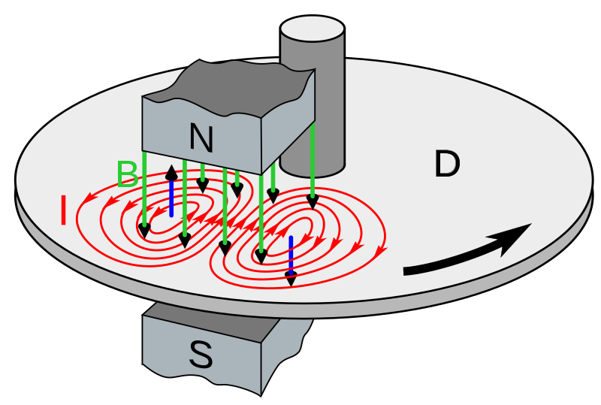

### The Right Hand Rule(s)

For reasons that are not easy to explain, there are two right hand rules that crop up in HSC physics. There are many varying versions of these rules, with pretty much the only commonality being that they use your right hand (funnily enough).

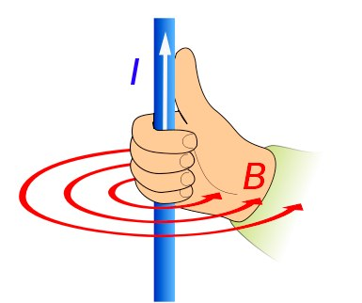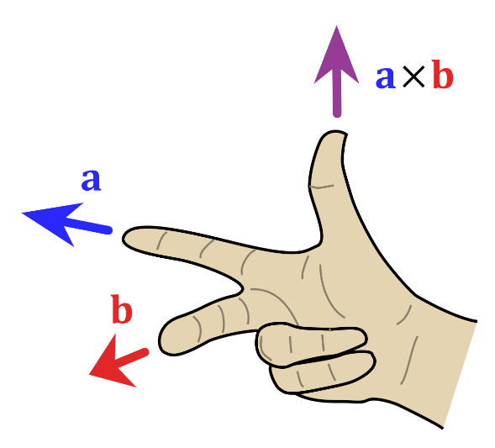

The way the first one works is when you see two things in an equation with the $⊥$ symbol between them, you point your pointer finger in the direction of that vector, then your middle finger in the direction of the other vector. Your thumb gives the direction of the final vector.

It is worth remembering that a negative (such as $q$ for an electron) will then reverse the direction that your thumb gave you, and that will be your final answer.

The one on the right is the right hand curl rule and is used to describe the magnetic field around a wire. You point your thumb in the direction of the current and then your other fingers curl in the direction of the field.

### The Motor Effect

This is the application of moving charges in a magnetic field. The motor effect is merely the notion that charges moving through a current carrying conductor will experience a force. As the charges experience a force, they will move, attracting the conductor with them. This is the mechanism through which the entire wire, not just the charges experience a force.

The magnitude of the force is given by $F=lIB\sin{θ}$ where $θ$ is the angle between the current vector and the field vector. As such, when the current and the magnetic field are parallel, there is no force (just as with a charged particle and its velocity). When the current and the field are parallel, the maximum amount of force is produced.

While this force is always perpendicular to the current, the force does not induce circular motion since the current is locked in a fixed direction by the fields in the conductor. As such this force can do work on the wire.

#### Deriving the Motor Effect

$$q\overset{⃑}{v}×\overset{⃑}{B}=\frac{d}{dt}\left(q\overset{⃑}{s}\right)×\overset{⃑}{B}=\left(\frac{dq}{dt}\overset{⃑}{s}+q\frac{d\overset{⃑}{s}}{dt}\right)×\overset{⃑}{B}=\left(\frac{dq}{dt}\overset{⃑}{s}+\overset{⃑}{0}\right)×\overset{⃑}{B}=s\frac{\overset{⃑}{dq}}{dt}×\overset{⃑}{B}=l\overset{⃑}{I}×\overset{⃑}{B}$$

### Force on Parallel Conducting Wires

Since the magnetic field produced by a current carrying conductor is given by $B=\frac{μ_{0}I}{2πr}$ 
 we can plug this into the motor effect equation and find the force on wire 1 due to the field of wire 2. (We shall assume the wires are parallel otherwise the force is different at different points along wire 1 due to the decay of the field).

$$F=lI_{1}B_{2}=lI_{1}\frac{μ_{0}I_{2}}{2πr}$$

$$\frac{F}{l}=\frac{μ_{0}}{2π}\frac{I_{1}I_{2}}{r}$$

It turns out that the force per length is the same for each wire. What is important to remember is the direction of the force and the $l$ term. In this case the $l$ term is the shortest length of one of the wires that is parallel to the other (i.e. if one wire is 1 m long and the other is 10 cm long and they are placed next to each other, $l=10 cm$).

The other thing to remember is the direction. It is possible to do the two right hand rules for the field and then the current direction, but the rule is that currents in the same direction attract and currents in the opposite direction repel (the way I remember it is that *opposites attract, except wires because they are special*).

### Motors

#### DC Motors

Motors are devices which take advantage of the Motor Effect to produce rotation.

There are two common questions which arise when considering the design of a motor:

1. How does one keep the torque uniform?
2. How does one keep the torque in the same direction?

The first problem of keeping the torque at a uniform strength across the rotation has two solutions. The first way to improve this is by using curved magnets. The curved magnets produce a magnetic field which, at the outer edge, is pointed towards or away from the centre. This type of field is known as a **radial** magnetic field.

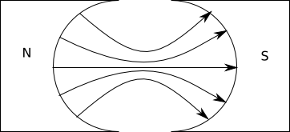

Because the field points in the same direction as the radius at the location of the arms, the angle between the force and the radius is a constant $90°$ at almost all times during the rotation. The end result is the torque produced is at a maximum value for all of the rotation (except when vertical).

Although this keeps the torque at a maximum for most of the rotation, the torque is not uniform due to the drop when the armature is vertical. To ensure the torque is completely uniform, there need to be more coils. If there are more coils, this drop of one armature as it reaches the vertical is counteracted by another coil at an offset. The more coils added to a motor, the more uniform the torque.

The second commonly considered problem with a motor is what happens when an arm of the armature (loop) changes from one side of the motor to the other (i.e. it becomes closer to the side with the North pole of the magnet).  
This would normally result in a change to the direction of the torque on the armature due to the direction of each arm changing from slightly upwards to slightly downwards or vice versa.   
This change in direction can be counteracted by a change in the current direction.

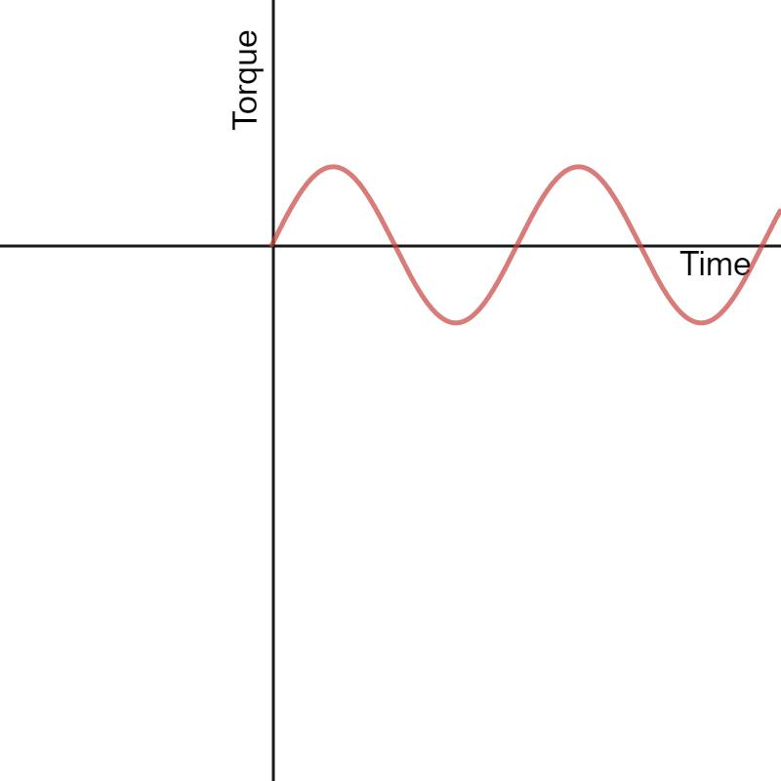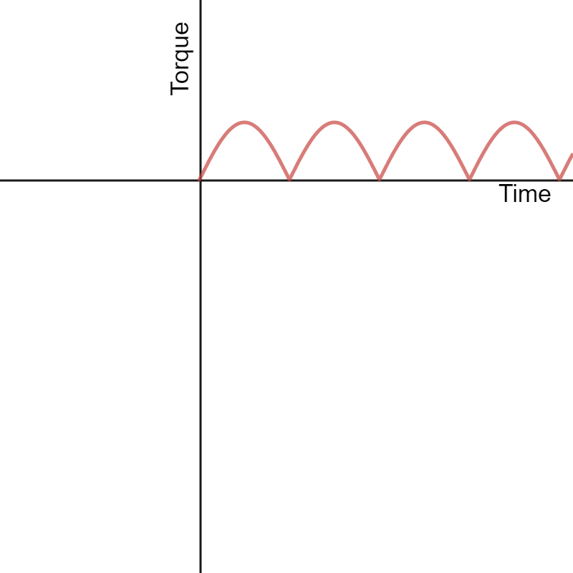

Torque where there is no change in current direction.

Torque where there is a change in current direction.

In a DC Motor, this change in current direction is achieved through a split-ring commutator, present in the image above. A split ring consists of semi-circular plates attached to each ending of the armature. The plates rotate with the motor and make contact with brushes, which are in turn connected to a voltage supply. As the motor rotates to this point, each plate breaks contact with a brush and connects to the other brush, changing the direction of the voltage across the armature. This then reverses the direction of the current and therefore the force. This acts as a sort of double reversal, keeping the torque in the same direction.

#### AC Induction Motors

An AC Induction motor works by utilising 3-phase AC power to create a rotating magnetic field inside the motor. This is analogous to the stator (external magnets) being rotated around the coil in a regular motor.

This induces a current in the coil which causes it to be ‘dragged’ by the field. The coil (or squirrel cage) inside the motor will be dragged with some torque due to the changing magnetic flux until it is rotating at the same speed as the field. The Squirrel Cage is a special type of coil which maximises magnetic flux and torque in this setup.

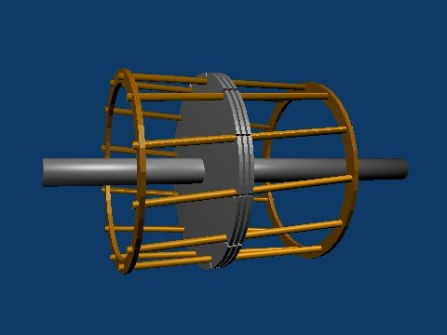

Credit: Meggar

### Generators

Generators work in reverse to motors, so instead of supplying power to turn a coil, a coil is turned, generating power.

The act of spinning the coil through a magnetic field creates a force on the electrons in the moving wires, generating a voltage. The voltage generated by this is the same as the back E.M.F. created when the motor is spinning and is in the same direction as when the motor spins in a given direction.

Due to a current being generated in the coil as it is rotated, there is also a force acting as a torque in the opposite direction, resisting the rotation of the generator. This force is described by the equation: $$\overset{⃑}{F}=l\overset{⃑}{I}×\overset{⃑}{B}$$ 
This can be rationalised by considering that if there was no resisting torque, or the torque acted in the other direction, there would be an infinite amount of energy generated (i.e. once it was started it would never stop or it would infinitely generate more energy).

#### DC Generators

A DC Generator makes use of the same equipment as a DC motor. As with motors, the current direction flips every half turn and, as a result, the current generated would be AC.  
To stop this from happening, a split-ring commutator is used, reversing the current again every half turn, keeping the current direction the same. In an ideal DC generator, the graph follows an $\left|\sin{ωt}\right|$ graph but in reality, there is a sudden drop before it reaches its minima each time (as the commutator loses contact slightly before the transition).

#### AC Generators

AC generators are actually rather simple as they use the same setup as a DC motor except without a commutator (use a slip ring instead). As already discussed, the direction of force in a DC motor swaps every half turn.

In a generator, because the rotation is in a constant direction and being created by an external entity, this reversal still occurs but instead it is the direction of the voltage being generated which swaps. As a result, the direction of the current swaps every half turn which, by definition, is the generation of an Alternating Current.  
This is carried away for use through a slip-ring commutator, which doesn’t swap the direction of the current. A slip-ring commutator can be thought of as though you attached an alligator clip to each end of the coil and magically made them unable to tangle.

### Transformers

Transformers perform a simple but important task: changing the voltage in an AC circuit. Transformers are made from two coils and a circular or rectangular iron core which both coils are wound around.   
One coil, called the primary coil, is connected to power and has an alternating current put through it (often 50Hz for Australia) which then generates an alternating magnetic field in the solenoid. This magnetic field then induces a magnetic field in the iron core, which then channels the magnetic field around the iron loop and through the other coil, called the secondary coil.  
The changing magnetic flux through the secondary coil caused by this process creates an E.M.F. which also alternates at the same frequency. By changing the number of turns of the secondary coil, the amount of E.M.F. produced changes. By increasing the number of coils, the voltage increases from the primary to secondary coils (step up) and be decreasing the number of turns the voltage drops (step down).

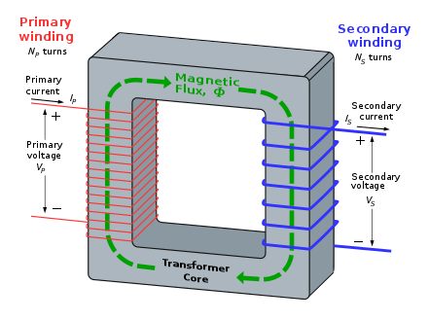Transformer equations rely on the assumption that energy is conserved in the voltage transformation from coil to coil. As a result, when a voltage step-up occurs, there must be a current step-down and vice versa.

Overall, ideal transformers obey the rule that the ratio of the voltages in each of the coils is also the ratio of the number of windings.

$$\frac{V_{p}}{V_{s}}=\frac{N_{p}}{N_{s}}$$

#### Laminations

Laminations are used in transformers to prevent eddy currents from being induced in the iron core. Eddy currents can be a big problem for the efficiency of transformers due to the fact that they use alternating current at high frequencies, which creates a changing magnetic field. Due to the frequency at which this changing magnetic field oscillates, the E.M.F. it would create is massive, which would normally create large eddy currents which would ruin the efficiency of the transformer. To counteract this, plastic laminations are used, parallel to the direction of the magnetic field within the metal core. The laminations reduce the area of the core to small sections, which prevents large currents from forming by reducing the maximum E.M.F. in each section to a smaller value. This increases the effectiveness of the core at channelling the $\overset{⃑}{B}$ field.

Potential $ε$

Laminations which prevent large eddy currents.

Resultant currents

#### Incomplete Flux Linkage

This is a somewhat nebulous term in the syllabus, but what it is referring to is the other assumption of the transformer: that the flux through one of the coils in the primary solenoid is the same as the flux through one of the coils in the secondary solenoid.

This means that there is perfect power transfer between the two solenoids and the power input is the same as the power output.

$$V_{p}I_{p}=V_{s}I_{s}$$

If there is imperfect flux linkage (which there almost always is), then this can be seen in a diagram with the magnetic field lines that begun inside the primary solenoid escaping the iron core. In reality this is hard to see, but its effects can be seen in that the power transfer is not perfect.

#### Why use transformers?

We use transformers mostly to send energy over long distances. For instance, power lines that run over roads need a low current so that they do not attract/repel each other and so that their alternating magnetic fields don’t cause what is effectively an EMP. As such, a transformer can make a 240V AC power supply into a 2400V AC power supply with a much lower current across power lines, with a transformer at the end that changes it back again when you get to the final destination.

## Electromagnetism Questions

### Question 1

A proton enters a uniform electric field generated between two oppositely charged plates with a potential of $V=48 J C^{-1}$ separated by a distance of $d=5 cm$. The plates are each $50 cm×50 cm$.

If the proton enters the field at $0.1 c$ directly in the middle of the plates, does it collide with the negatively charged plate?

$$0.1 c$$

$$5 cm$$

$$50 cm$$

$$0 V$$

$$48 V$$

### Answer 1

First, we calculate the electric field and therefore the force.

$$E=\frac{V}{d}$$

$$F_{y}=ma_{y}=qE$$

$$a_{y}=\frac{F}{m}=\frac{q_{p}V}{m_{p}d}$$

But $E$ is pointed down, so $a_{y}$ is negative:

$$a_{y}=-\frac{q_{p}V}{m_{p}d}$$

Now the standard equations of motion can be applied. We want to find when the proton reaches the same $y$ height as the negative plate, so when it is $2.5 cm$ below where it started $\left(-\frac{d}{2}\right)$.

$$s_{y}=\frac{1}{2}a_{y}t^{2}+u_{y}t$$

$$s_{x}=\frac{1}{2}a_{x}t^{2}+u_{x}t$$

Since it is initially only travelling in the horizontal direction $u_{y}=0$ and since the field is in the $y$ direction, the force in the $x$ direction is 0.

$$s_{y}=\frac{1}{2}a_{y}t^{2}$$

$$s_{x}=u_{x}t$$

Now solve for the time by setting our conditions for the $y$ displacement:

$$-\frac{d}{2}=\frac{1}{2}\left(-\frac{q_{p}V}{m_{p}d}\right)t^{2}$$

$$t^{2}=\frac{d^{2}m_{p}}{q_{p}V}$$

Now we can substitute this into our $x$ formula and figure out whether the proton will collide with the plate.

$$s_{x}=0.1c \sqrt{\frac{d^{2}m_{p}}{q_{p}V}}≈99m$$

So no, the proton well and truly misses the plate, by quite a lot.

### Question 2

A DC Electric motor is used to lift a load vertically. As the load is lifted, weights are added to increase the load.

1. Explain how the rotation speed of the motor changes as the load increases
2. Explain how the current in the coils change as the load increases

### Answer 2

1. As the mass is increased the required force to lift them becomes greater. The force output by the motor (assuming it has a radial magnetic field) is $F=\frac{τ}{r}$ where $τ$ is its torque output and $r$ is the radius where the torque is output.

In general, a motor will have its peak torque at 0 angular velocity and it will have 0 torque at its highest angular velocity. Since torque decreases with increasing angular velocity, the opposite is also true. Therefore as the torque required to lift the load increases, provided a constant power is supplied, the speed will decrease.

This is due to the emf which is produced as it rotates increasing with its rotational speed. This emf opposes the input voltage, satisfying the total voltage equation $V_{T}=V_{app}-\left|ε\right|$.

1. As the load increases the speed will decrease. As the speed decreases the back emf decreases, increasing the total voltage through the circuit   
   ($V_{T}=V_{app}-\left|ε\right|$). Therefore, by $V=IR$, the increase in voltage will increase the current.

### Question 3

Calculate the force between the two current carrying wires below and describe its direction.

$$I=2.0 mA$$

$$I=10 mA$$

$$10 cm$$

$$15 cm$$

$$7.0 cm$$

### Answer 3

The most tricky part of this is remembering that the common length $l$ is the shortest length of wire $\left(10 cm\right)$. Other than that this is just plug and play:

$$\frac{F}{l}=\frac{μ_{0}}{2π}\frac{I_{1}I_{2}}{r}$$

$$\frac{F}{10×{10}^{-2} m}=\frac{μ_{0}}{2π}\frac{\left(2×{10}^{-3}A\right)\left(10×{10}^{-3}A\right)}{7×{10}^{-2} m}$$

$$F≈5.7×{10}^{-12} N \left(2 s.f.\right)$$

Since the wires are in the same direction this force is attractive.

### Question 4

An electron enters the magnetic field as shown below. If it is to hit the target, what speed must it enter the field with?

Use values of $r=1.00 cm$ and $B=3.00 μT$

$$r$$

$$\overset{⃑}{B}$$

$$\overset{⃑}{v}$$

### Answer 4

To solve this, we just need to set $F_{B}=F_{c}$ (since this condition is always true for a single charged particle in a uniform magnetic field).

$$qvB\sin{θ}=\frac{mv^{2}}{r}$$

Since the field is vertically down and the velocity is horizontal they are always perpendicular (i.e. $\sin{θ}=1$).

$$qvB=\frac{mv^{2}}{r}$$

$$v^{2}=qvB\frac{r}{m}$$

$$v=\frac{qBr}{m}$$

This gives a final answer for $v$ of:

$$v≈5.28×{10}^{3} m s^{-1} \left(3 s.f.\right)$$

### Question 5

Calculate the force vector on the current carrying wire below.

$$θ=15°$$

$$I=5.0 mA$$

$$B=7.0 μT$$

$$l=22 cm$$

### Answer 5

The force on the wire is given by $F=lIB\sin{θ}$ and the direction is given by the right hand rule.

The strength of the force is $F≈2.0×{10}^{-9} N \left(2 s.f.\right)$ and the direction is into the page.

### Question 6

Compare the DC motor and the AC induction motor. Include:

* Explanation of the squirrel cage and its function
* Discussion about the differences in how/when they are used

### Answer 6

*For this sort of question in the HSC, you must draw a diagram for each motor. It is difficult but you should replicate the images from earlier as best you can here to aid your description.*

The function of a DC motor is to convert electric potential energy into kinetic energy. DC motors run on direct current (DC), whereby current flows in a single direction. A typical DC motor is comprised of a stator and a rotor. The stator (the stationary part of the motor) holds the casing of the magnets, input wires and brushes. The rotor (the rotating part of the motor) holds the armature and commutators.

A generated current flows through the circuit and through the armature / coils in a loop. As there are current carrying conductors in a magnetic field, a force is produced in accordance with the Motor Effect. As the current flows around the loop of the armature, a force is produced in opposite directions on opposing sides and thus a torque is induced. The function of the commutator is to switch the direction of the current once a half rotation of the armature has occurred. This ensures that the rotation of the armature and thus the motor is either constantly clockwise or anti-clockwise.

The function of an AC induction motor is the same as the DC motor. However, AC motors utilise the principle of electromagnetic induction using an alternating current (AC) in lieu of direct current (DC). A typical AC induction motor contains a cylindrical structure with metal rods around the edge, connecting two circular poles of the cylinder – this is known as a “squirrel cage”.

An alternating current is supplied to the coils of the electromagnets, and creates an oscillating magnetic field that induces a current in the squirrel cage. As the rods inside the squirrel cage are current-carrying conductors in a magnetic field provided by the stator, there is a force experienced by each connecting rod. AC induction motors exploit this change in the magnetic field to produce a rotation.

AC induction motors are self-starting, and due to the minimisation of moving parts they are reliable and economical. Their simplicity of design and high efficiency makes them useful in appliances such as blenders and microwaves. The commutators and brushes that are part of the DC motor design often wear out, and overall is a more expensive solution than the AC induction motor. However, DC motors are sometimes prioritised as the electric motor speed can be controlled externally by changing the voltage applied to the armature.

### Question 7

A transformer converts $240V$ AC at $1000 W$ to $2400V$ AC with a secondary coil with $1000$ windings. Describe the power and current output for an ideal transformer with this output, with reference to the number of windings on each of the sides of the transformer.

Then, with reference to relevant theory, describe how energy might be lost within the system.

### Answer 7

For an ideal transformer, the power input is equal to the power output. Using $P=VI$:

$$1000 W=2400 V⋅I_{s}$$

$$I_{s}≈0.42 A$$

The ratio of the voltages is also given by the ratio of the coil windings (since this is the ratio of the flux that passes through each coil and changing flux produces a voltage proportional to the number of windings):

$$\frac{V_{p}}{V_{s}}=\frac{N_{p}}{N_{s}}$$

$$N_{p}=1000⋅\frac{240}{2400}=100$$

So, as seen here, the primary coil in an ideal transformer would have $100$ turns.

If we ignore the assumption that the transformer is ideal, there are two causes for the loss of power which will be observed.

The first is a lack of flux linkage (a phenomena where not all of the magnetic field lines produced within the iron core remain within the iron core). This reduces the ratio of the fluxes through the coils (since it means the overall magnetic field in the secondary coil is always lower than the ideal case). This in turn reduces the voltage that can be generated.

The other is due to eddy currents produced in the iron core. As the current passes through the primary coil it produces a magnetic field. As the current direction alternates the field strength and direction changes with it, causing a changing magnetic flux though the iron core. This changing flux then creates circular electro motor forces which try to pull electrons in the iron into circular currents.  
These eddy currents, even if reduced with laminations, produce a magnetic field which opposes that of the created magnetic field, reducing the overall flux. The eddy currents also act to dissipate energy through their own power loss due to electric resistance. As a result, the total power output must be lower than that input.

# Module 7 – The Nature of Light

## Constants

The Speed of Light $c=3.00×{10}^{8} \left(m s^{-1}\right)$  
Permittivity of Free Space $ε_{0}=8.854 ×{10}^{-12}$ ($A^{2}s^{4}kg^{-1}m^{-3}$)

Permeability of Free Space $μ_{0}=4π ×{10}^{-7}$ ($NA^{-2}$)

Planck Constant $h=6.626×{10}^{-34} \left(kg m^{2} s^{-1}\right)$

Wein’s Displacement Constant $b=2.898×{10}^{-3} \left(m^{2}s^{-2}K^{-1}\right)$

## Equations

*Describes the angular location of the $m^{th}$ bright spot on a wall due to double slit interference (or dark spots for single slit interference).*

$$d\sin{θ}=mλ$$

*Describes the angular location of the $m^{th}$ bright spot due to single slit interference ($+$); and the $m^{th}$ dark spot on a wall due to double slit interference ($-$).*

$$d\sin{θ}=\left(m±\frac{1}{2}\right)λ$$

*Wein’s Law for Blackbody radiation.*

$$λ_{max}=\frac{b}{T}$$

*Malus’ Law - The intensity of light that has passed through a polarising filter with $θ$ the difference between the angle of the polarizing filter’s axis and the polarization direction of the light.*

$$I=I_{0}\cos^{2}{θ}$$

*The maximum amount of kinetic energy an electron can receive from a photon of some frequency $f$ where $ϕ$ is the work function of the material and $f_{0}$ the critical frequency of the material.*

$$K_{max}=hf-ϕ$$

$$ϕ=hf_{0}$$

## Course Notes

### Attempts to Measure the Speed of Light

#### Galileo

Galileo and his assistant stood on top of hills a reasonable distance (a few kilometres) apart. Galileo uncovered his lamp. His assistant uncovered his lamp once he saw Galileo’s light and Galileo noted the time it took for him to see the light again.  
He compared this to the time measured at a very small distance (i.e. human reaction time in his lab) and noticed that there was almost no difference. From this he concluded that the speed of light was a minimum speed of the distance between the hills over human reaction time measured in the lab and could be anywhere from this speed to infinite.

#### Romer

Romer was making measurements of the time at which the eclipse of one of Jupiter’s moons Io occurred. Romer noticed that the time at which it appeared to occur followed a sine curve, with a period of one year.   
He reasoned that this curve was occurring due to the orbit of the earth around the sun and that this delay must therefore be due to the speed of light travelling longer distances as earth moved to the other side of the sun.

Using the known radius of earth’s orbit, he estimated the speed of light to be $220, 000, 000 m s^{-1}$

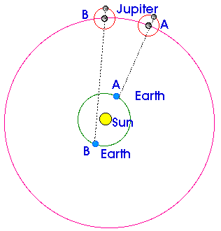

#### Fizeau

Fizeau used a toothed wheel with known angular speed and angular distance between the teeth. Fizeau passed light pulses through the holes in the teeth and then sped the gear up until the light pulses did not make it through. This meant that the next tooth was getting in the way of the pulse. Because he knew the angular separation of the teeth and the angular speed of the wheel, he calculated the minimum and maximum time the light could be taking after passing through the gap to make it back and hit the tooth. $\left(t=\frac{1}{nf}, n=teeth\right)$

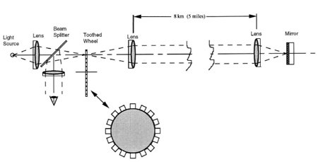Using the known (large) distance between the mirror and the wheel, he calculated the speed of light using $c=\frac{d}{t}$ to be $3.15×{10}^{8} m s^{-1}$

#### Michelson

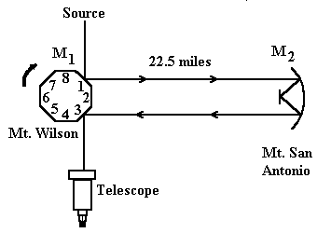Michelson’s rotating mirror experiment is very similar to Fizeau’s experiment in that it relied on the precise lining up of rotating objects with a ray of light. Michelson’s experiment was, however, more precise than Fizeau’s as it could use a continuous beam of light rather than pulses.

At first, the mirror is stationary such that the beam perfectly reflects towards the observer. If the mirror rotates even a little bit, the beam will not reach the observer. The key part of this is that the mirror must be in this orientation for the light to reach the observer.

Once the mirror starts rotating, the beam doesn’t reach the observer because by the time the light has travelled the distance, the mirror has rotated to a different orientation.

The next time the beam will be seen is when the mirror is rotating such that:

* The beam reflects off side 1
* As the beam travels the distance, the mirror continues to rotate
* When the beam reaches the mirror, it has done exactly $\frac{1}{8}$ of a rotation and is back in the ideal state, with the light reflecting to the observer from side 2

This means the time taken for the beam to travel the large distance is $t=\frac{1}{8f}$ and the speed is $c=\frac{2d}{t}$

Michelson’s measured the speed of light to be $299, 979, 000 m s^{-1}$ (withing 0.1%)

#### Hertz

Hertz set out to experimentally prove two of Maxwell’s predictions. As such he did two main things:

1. He assumed that light was an electromagnetic wave
2. He used the know relationships for waves to find the speed

If the assumption could be shown to be true and then the speed measured closely matched the prediction, then he could verify Maxwell’s prediction.

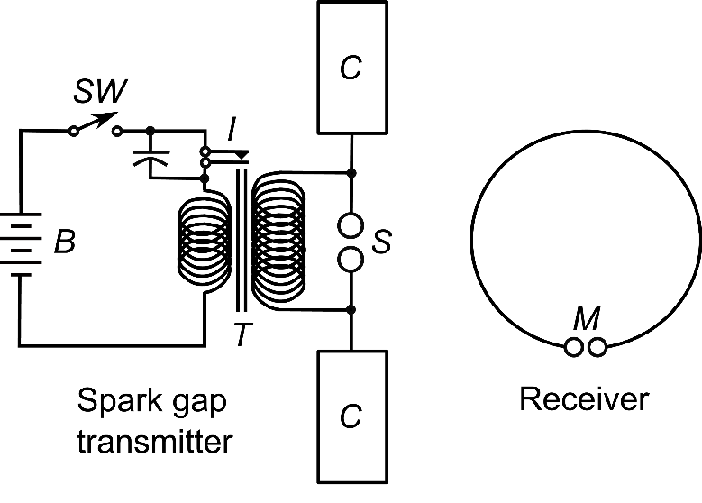

Source: Chetvorno

The experiment above cause a spark of electrons undergoing a high acceleration to pass between the spark gap. This created radio waves which were emitted in all directions (which were already known to be a type of light). The setup was created in a way that Hertz already knew the frequency of the wave.

By placing a metal reflector some distance from the emitter, he created a standing wave pattern between the emitter and the plate, where the gap between nodes is half the wavelength.

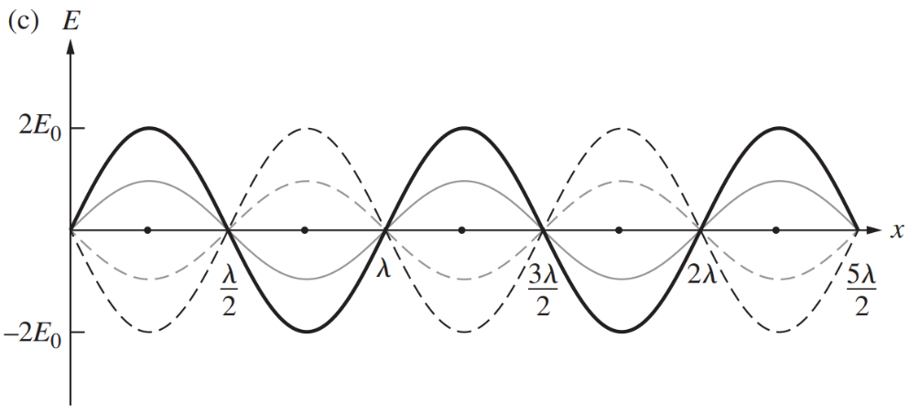

Now comes the assumption. If light is an electromagnetic wave, then the oscillating magnetic field of this standing wave will induce a current (and therefore a spark) in the loop detector at all points except the nodes. This was indeed the case.

By measuring the distance between points where there was no induced spark, Hertz measured the wavelength of the wave (which he already knew the frequency for).

Due to experimental error in calculating the frequency output of the device and error induced by an inversion of the wave upon reflection, Hertz could only conclude that the speed of light was finite and approximately $3×{10}^{8} m s^{-1}$ (but with a large degree of uncertainty). This was enough to confirm Maxwell’s hypothesis.

More recent attempts at his experiment with better data (but the same experimental setup) give a value of $c≈3.4×{10}^{8} m s^{-1}$.

### Waves need a medium – so what about light?

Once physicists discovered that light was a wave, they began to hypothesise about what is the medium through which it travels?

#### Absolute Space and Time

When Newton was developing his theories, he reasoned that there must be some universal clock and universal zero point. This seemed particularly reasonable since all phenomena observed at the time appeared to happen at the same rate and across the same distances.

#### The Luminiferous Aether

Based on Newton’s idea of absolute space informed the construction of a theoretical medium called the aether. The aether was meant to be fixed to the universe’s zero point and was the medium through which light travelled with speed $c$.

This meant that as Earth travelled through the universe, it should have some velocity relative to the aether. This would create ‘aether winds’ which would slow down or speed up light depending on the relative velocity of the Earth to the respective light ray.

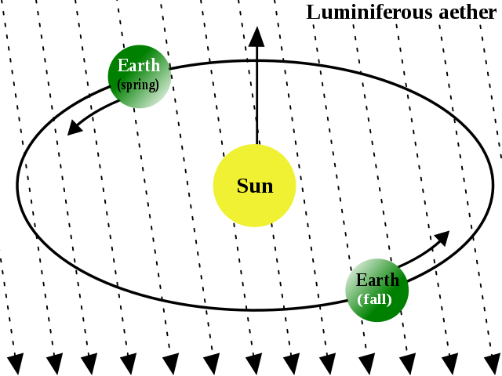

Source: Cronholm144

#### Michelson-Morley Experiment

The Michelson-Morley experiment set out to detect these aether winds. They hypothesised that at a certain point in time and certain spot on Earth there is a given aether wind direction. Using their setup (below), should they rotate the apparatus, the relative speeds of each light ray will differ (they should bend depending on the angle to the aether wind) and a variable diffraction pattern should be produced as the apparatus is rotated.

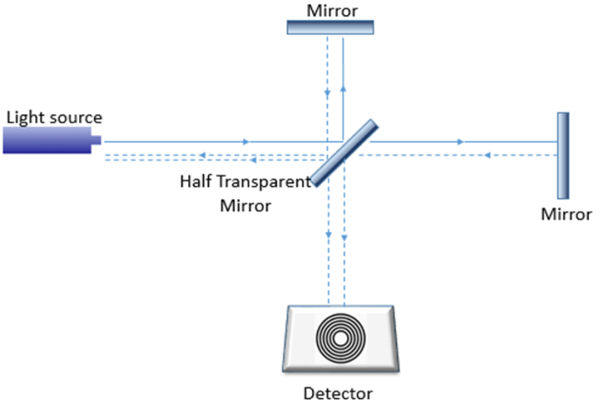

Source: Hany Ali Hussein

The apparatus was floating on a mercury bath (because basically everything floats on mercury) allowing for it to be rotated smoothly while also isolating it from any vibrations from footsteps and the like.

The experiment yielded a null result (meaning nothing could be concluded). Due to the great precision of the experiment, and verification through repetition by other labs, it meant that the theory of the aether had to be revisited.

Although it was a null result, the discrepancy between the actual result and the theorised result meant that the theory had to be adjusted (it caused a paradigm shift).

#### The Actual Medium for Light

The most current model of light says that there are magnetic and electric fields which permeate through all of space and it is the fields themselves which are the medium for light.

Waves need a medium because they need something to wave however it is the fields which wave, so light doesn’t need a physical medium. The medium is the fields as they are what do the waving.

## Maxwell

Maxwell’s contribution to the model of light is perhaps the most influential but also the most difficult to explain. Maxwell is still one of the most influential physicists to this day and played a key roll in uniting electricity and magnetism.

He did this by taking all of the concepts those before him had figured out and connected the dots so that it all made sense. Before Maxwell there were lots of equations that described the electric and magnetic fields and only one, the Faraday-Lenz law which linked the two. Maxwell was then able to find a similar equation that linked the magnetic field to a changing electric field and ‘completed’ electromagnetism.

A little known fact is that it was not until years after this that Heaviside managed to combine Maxwells approximately 20 equations into the 4 “Maxwell’s Equations”.

|  |  |
| --- | --- |
| **Integral Form** | **Vector Form** |
| $$∯{\overset{⃑}{E}∙d\overset{⃑}{A}}=\frac{Q_{enc}}{ε_{0}}$$ | $$\overset{⃑}{∇}∙\overset{⃑}{E}=\frac{ρ}{ε_{0}}$$ |
| $$∯{\overset{⃑}{B}∙d\overset{⃑}{A}}=0$$ | $$\overset{⃑}{∇}∙\overset{⃑}{B}=\overset{⃑}{0}$$ |
| $$\oint{\overset{⃑}{E}∙d\overset{⃑}{l}}=-\frac{∂ϕ_{B}}{∂t}$$ | $$\overset{⃑}{∇}×\overset{⃑}{E}=-\frac{∂\overset{⃑}{B}}{∂t}$$ |
| $$\oint{\overset{⃑}{B}∙d\overset{⃑}{l}}=μ_{0}I_{enc}+μ_{0}ε_{0}\frac{∂ϕ_{E}}{∂t}$$ | $$\overset{⃑}{∇}×\overset{⃑}{B}=μ_{0}\overset{⃑}{J}+μ_{0}ε_{0}\frac{∂\overset{⃑}{E}}{∂t}$$ |

$ρ=\frac{dq}{dV}$* (charge per volume), $J=\frac{dI}{dA}$ (current per area)

These equations link the two fields to each other and give the result that a changing electric field causes a magnetic field and a changing magnetic field produces an electric field.   
Due to this, electromagnetic waves with speed $c=\frac{1}{\sqrt{μ_{0}ε_{0}}}$ are possible.

What is important to note is that Maxwell did not ‘discover’ that light is an electromagnetic wave per se, he merely found that this value for $c$ was very close to the value Romer had found for the speed of light and therefore proposed that the most likely candidate for light was electromagnetic waves.

### Diffraction

#### Double Slit

Double slit interference is somewhat easy to understand if you think about how waves work.

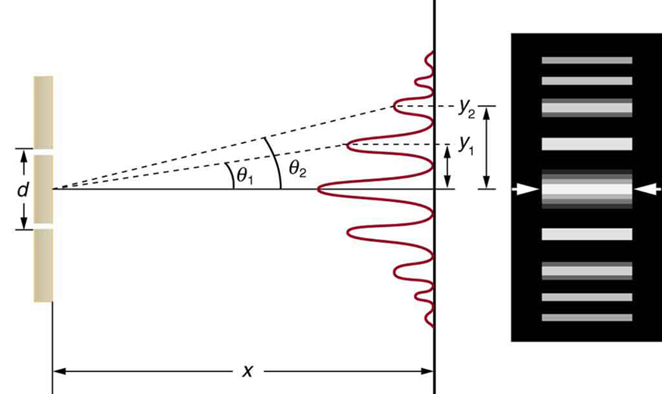The assumptions of a double slit setup are that $X≫d$ and therefore that $\sin{θ}=\tan{θ}$

##### Formulae:

|  |  |  |
| --- | --- | --- |
| **Maxima** | | **Minima** |
| $$d\sin{θ_{m}}=mλ$$ | | $$d\sin{θ_{m}}=\left(m-\frac{1}{2}\right)λ$$ |
| **Distance from Centre of Maxima / Minima** | | **Gap Between Consecutive Maxima / Minima** |
| $$y=\frac{mλX}{d}$$ | $$y=\frac{\left(m-\frac{1}{2}\right)λX}{d}$$ | $$∆y=\frac{λX}{d}$$ |

##### Derivation of Formulae

$$y$$

$$θ$$

$$d$$

$$∆p$$

$$θ$$

$$X$$

###### Maxima

Condition for constructive interference is when the waves are in phase. Therefore, the distance covered by one wave must be an integer multiple of the wavelength (since they begin in phase).

Since $∆p=mλ, m∈Z$

$$\sin{θ}=\frac{∆p}{d}$$

$$d\sin{θ}=mλ$$

###### Minima

Similarly, deconstructive interference occurs where the waves are out of phase and therefore where the path difference is half a wavelength. The first minima will occur where the path difference is half a wavelength.

Since $∆p=mλ-\frac{1}{2}λ, m∈ Z$

$$\sin{θ}=\frac{∆p}{d}$$

$$d\sin{θ}=\left(m-\frac{1}{2}\right)λ$$

###### Height and Width of Peaks on Wall

|  |  |
| --- | --- |
| ***Height*** | ***Width*** |
| $$\sin{θ}=\frac{mλ}{d}=\tan{θ}=\frac{y}{X}$$ $$y=\frac{mλX}{d}$$ | $$∆y=\frac{\left(m+1\right)λX}{d}-\frac{mλX}{d}$$ $$∆y=\frac{λX}{d}$$ |

#### Single Slit (Not explicitly in syllabus)

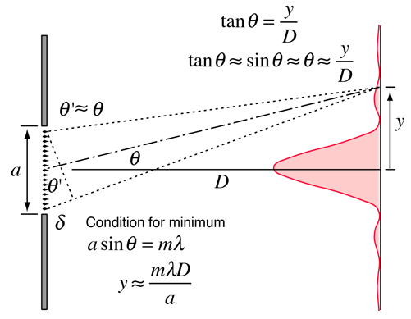Single slit interference is only qualitatively assessable in Yr. 12 HSC Physics however it isn’t terribly difficult. The main difference is that while in single slit interference the width of the centre peak is $2 ∆y$.

##### Formulae:

|  |  |  |
| --- | --- | --- |
| **Maxima\*** | | **Minima** |
| $$a\sin{θ_{m}}=\left(m+\frac{1}{2}\right)λ$$ | | $$a\sin{θ_{m}}=mλ$$ |
| **Distance from Centre of Maxima / Minima** | | **Gap Between Consecutive Maxima / Minima** |
| $$y=\frac{\left(m+\frac{1}{2}\right)λX}{a}$$ | $$y=\frac{mλX}{a}$$ | $$∆y=\frac{λX}{a}$$ |

\**There is technically no formula for maxima, but this gives the halfway point between two minima*

For Derivations see Khan Academy’s video:

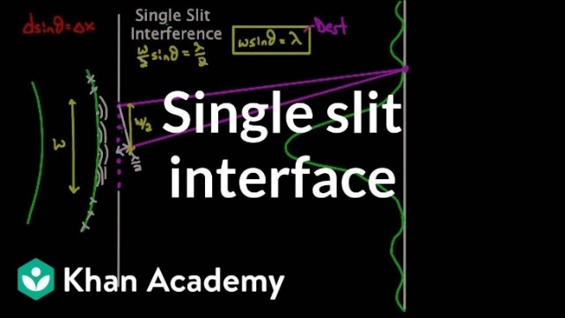

<https://www.khanacademy.org/science/physics/light-waves/interference-of-light-waves/v/single-slit-interference>

### The Quantum Nature of Light

#### Blackbody Radiation

A blackbody is an object which is a perfect absorber of all frequencies of light. It can be said that these objects have an absorptivity of 1. When you work through the maths, it turns out that objects with an absorptivity of 1 also have an emissivity ($e$) of 1, meaning that they are perfect emitters.

This is why only black bodies are studied, as any other object requires that we adjust for it’s differing emissivity.

##### The Ultraviolet Catastrophe

‘The Ultraviolet Catastrophe’ is so named due to what is possibly the worst prediction to come from physics. Classical thermodynamics and electromagnetism predicted that a hot black body should emit an exponentially large amount of light in the ultraviolet, x-ray and gamma-ray side of the light spectrum. This violated both common sense and conservation of energy and was the first hint at a quantum nature of light.

Thermodynamics is also known as statistical mechanics and as such, the heat and light output of a blackbody is probabilistic (or statistical) in nature (its why the curve is a curve and not a bar graph). The peak light emission wavelength is derived by calculating the highest probability interaction between subatomic particles at a certain temperature and therefore all other wavelengths will have a lower probability of being produced.

##### The Mechanism for Blackbody radiation

The classical way blackbody radiation is produced is by the acceleration of charges when atoms and molecules collide and change velocity. When this occurs, the accelerating charges produced light waves and the principle of probability and temperature distributions still holds.

The current theory is defined by Wein’s law:

$$λ_{max}=\frac{b}{T}, b=2.898×{10}^{-3} m^{2}s^{-2}K^{-1}$$

This equation gives the wavelength of light that is emitted by the body at the greatest intensity (it’s the peak on the curve).

#### The Photoelectric Effect

The Photoelectric effect was the first definitive evidence for the quantum nature of light as it completely contradicted classical electromagnetism. Although blackbody radiation was unsolvable by classical physics, it did not completely contradict it, at least on a fundamental level.

Classical Electromagnetism says that the power output (energy per second) of a wave is proportional to its intensity:

$$P=IA$$

It was therefore completely reasonable to assume that the greater the power of light, the greater the amount of energy the light would give electrons. Therefore, the energy electrons possess after being vibrated by a light wave should be proportional to the power of the light wave. This was not the case.

Instead, the energy absorbed by an electron was a function of the frequency (intensity and therefore power is not a function of frequency at all). This eventually led Einstein to conclude that this must be due to light coming in packets with energy $E=hf$ and intensity being due to an increase in the number of packets (eventually called photons) striking the surface.  
This was the beginnings of the quantised understanding of light.

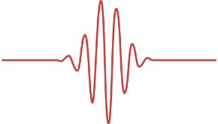

##### The Work Function $\left(ϕ\right)$

The work function is the lowest amount of potential energy which an electron possesses while part of the material. This is what gives rise to $K_{max}$ rather than just $K$ as it is the lowest amount of resistance the material provides to the electron being removed.

##### The Experimental Setup

The experiment is setup such that light is shone onto one of two parallel plates. A voltage can be applied to the plates so that there is an electric field between the two plates. This electric field can be setup to oppose the velocity of the emitted electrons.

Since the work done by the field is $W=qV$, if the work done by the field is greater than the maximum kinetic energy of the electrons, then the electrons will stop before they hit the other plate. So, if $V=\frac{K_{max}}{q}$ then no current will be detected. As such, if an electric field is established such that it just stops all electrons then $qV=hf-ϕ$

$$∴ϕ=hf-qV$$

### Polarisation

Polarised light is light with an electric field which only oscillates along one axis.

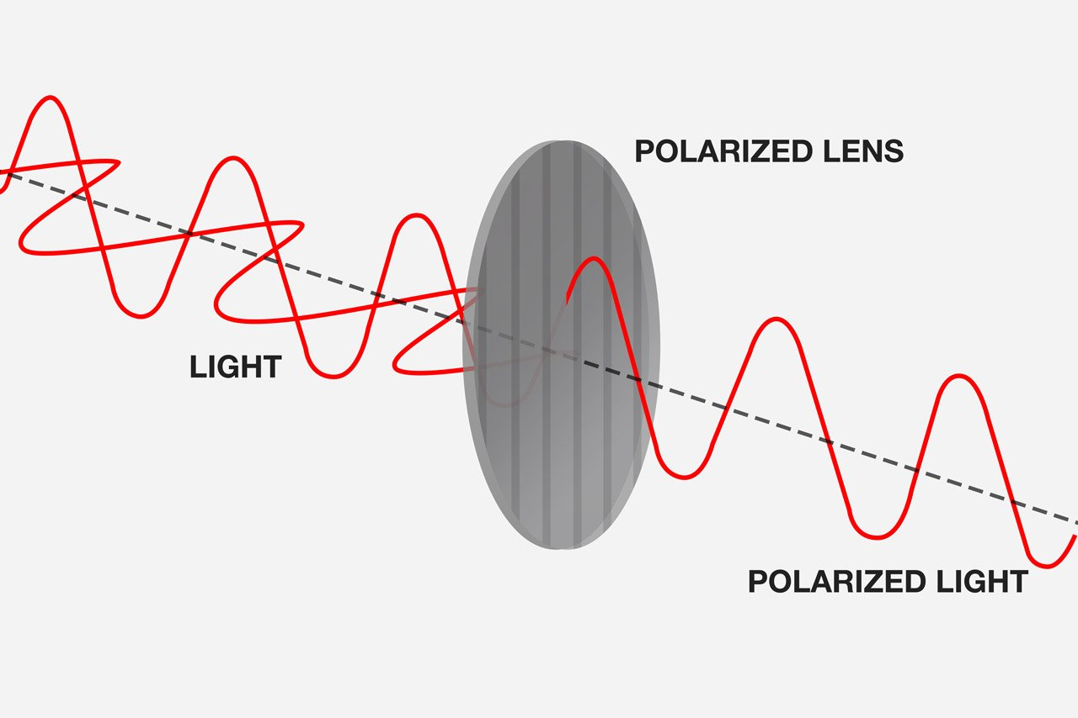Polarisation is typically understood using a wave model of light and splitting the field vector into components. In reality, it is a quantum phenomenon, with the polarisation of a photon being a function of its spin, something which is based on probabilities.

#### Wave Model – Derivation of Malus’ Law

It is somewhat easy to derive Malus’ Law when considering the assumptions of polarisation. If we consider light of a single polarisation direction. If we assume that a polariser blocks all electric field components of a light ray which are perpendicular to its axis, then we can consider the following:

A light ray is shone onto a polariser with its electric field $E_{0}$ oscillating on an axis at some angle $θ$ from the axis of the polariser.

$$θ$$

$$E_{0}$$

The (peak) component of the electric field which will be let through is the parallel component.

$$I=\frac{E^{2}}{2cμ_{0}}$$

$$E=E_{0}\cos{θ}$$

$$E^{2}=E_{0}^{2}\cos^{2}{θ}$$

$$\frac{E^{2}}{2cμ_{0}}=\frac{E_{0}^{2}}{2cμ_{0}}\cos^{2}{θ}$$

$$I=I_{0}\cos^{2}{θ}$$

#### Quantum Model

The quantum interpretation of light makes polarisation much harder to understand, but so is the nature of quantum. In reality, intensity is proportional to the number of photons which strike a surface. Photons possess a property called spin and this determines the direction of their electric field oscillation. When a photon is travelling through space, there is a degree of uncertainty in its spin. When a photon hits a polariser, it is interacting with it and therefore, its wave functions will collapse, and its spin will lose its uncertainty. The probability that the photon’s spin aligns with the polariser is:

$$P\left(align\right)=50\%$$

After this, the photons which pass through are all 100% aligned with the polariser. Should they come into contact with an analyser at an angle $θ$ to their polarisation axis, the probability that they will change their spin axis to the new spin axis is given by:

$$P\left(align\right)=\cos^{2}{θ}$$

(There are some very complicated calculations that can be done to figure this out with quantum physics but eventually you get this result).

[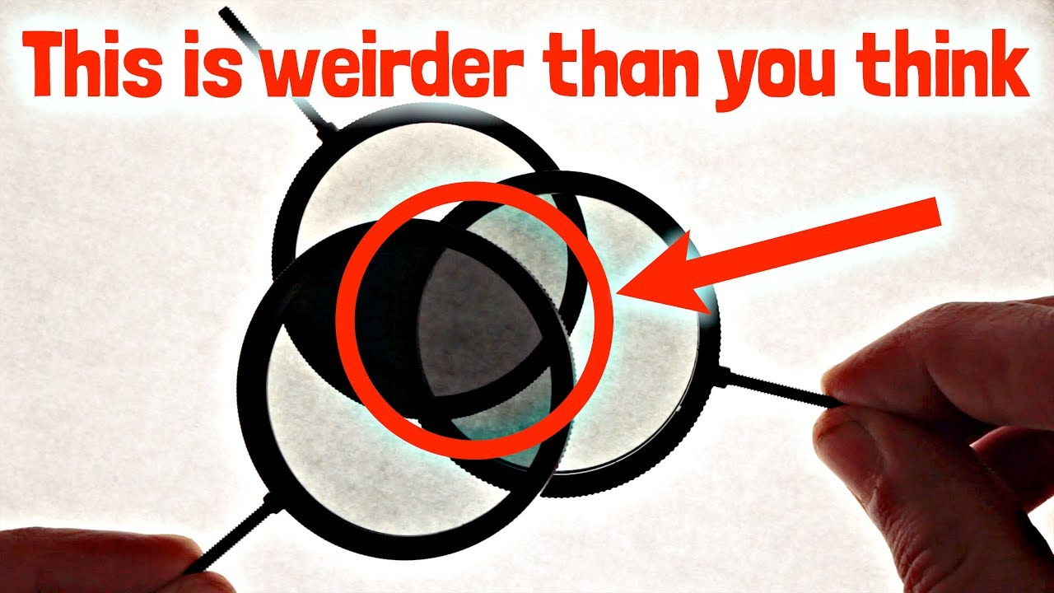](https://www.youtube.com/user/minutephysics)This is particularly evident with three polarisers which are at different angles to each other (see [minutephysics](https://www.youtube.com/user/minutephysics)’ video on the topic):

<https://www.youtube.com/watch?v=zcqZHYo7ONs>

### Light has Momentum?

Many teachers will mention that light has momentum and can move objects very slightly. This is due to the fact that $E=mc^{2}$ is only true for an object at rest.

The actual equation is:

$$E^{2}={\left(mc^{2}\right)}^{2}+{\left(pc\right)}^{2}$$

Where $p$ is the momentum.

Light has no mass, so the first term goes to zero.

$$E^{2}={\left(pc\right)}^{2}$$

$$E=pc$$

And since we know light has energy, it must have momentum. This is why light can cause small metal fans to move in vacuum chambers.

## Model of Light Questions

### Question 1

Explain how the model of light has progressed throughout history with reference to:

* Newton
* Huygens
* Young
* Maxwell
* Malus
* Einstein
* Schrodinger

### Answer 1

Newton was the first person to publish a formal theory of light, describing it as a stream of ‘corpuscles’ (particles) travelling at an infinite speed.

Huygens proposed a wave model of light where he instead modelled it as a sort of ripple in some ever-present field. Linked to this theory were the behaviours such as diffraction and refraction, with the only truly contradictory proposition to Newton being the requirement that light have a finite speed.

Young’s double slit experiment where he observed diffraction of light confirmed Huygens’ theory that light is a wave.

Maxwell extended this theory, explaining what that wave was. He described light as an electromagnetic wave with speed $v=\frac{1}{\sqrt{μ_{0}ε_{0}}}$.

Malus again gave support for the wave model with his law of polarisation ($I=I_{0}\cos^{2}{θ}$), which is itself a logical deduction from the wave theory.

Einstein proposed that light could still be modelled as a stream of packets or particles (called photons). This was due to the experimental evidence from the photo-electric effect where light could be seen to only transfer amounts of energy proportional to its frequency ($E=hf$).

Schrodinger extended on both theories, modelling light as a wave of probabilities which displays many particle-like properties.

### Question 2

Describe Maxwell’s contribution to the development of the model of light.

### Answer 2

Maxwell’s unification of Electromagnetism into 4 key equations allowed him to consider mathematically a situation without any charges or current:

|  |  |
| --- | --- |
| $$\overset{⃑}{∇}×\overset{⃑}{E}=-\frac{d\overset{⃑}{B}}{dt}$$ | $$\overset{⃑}{∇}×\overset{⃑}{B}=μ_{0}ε_{0}\frac{d\overset{⃑}{E}}{dt}$$ |

He was then able to show that a solution to these equations was a wave with mutually perpendicular $\overset{⃑}{E}$ and $\overset{⃑}{B}$ fields that moves with a speed $v=\frac{1}{\sqrt{μ_{0}ε_{0}}}$.

This speed was very close to Romer’s measurement of the speed of light, so it was then reasoned that light must be an electromagnetic wave.

### Question 3

A photon of wavelength $λ=375 nm$ is incident on a surface with a work function of $ϕ=2.0 eV$.

Calculate the energy in $eV$ of the photon and the maximum kinetic energy of any ejected electrons.

### Answer 3

We know the energy of a photon is given by $E=hf$ and $c=fλ$

So, we get $E=\frac{hc}{λ}=5.3008×{10}^{-19} J≈3.3 eV \left(2 s.f.\right)$

The maximum kinetic energy is given by $K_{max}=hf-ϕ=E-ϕ=1.3 eV$

### Question 4

Two small slits are separated by a distance of $0.300 mm$ with a monochromatic source at $λ=615 nm$ incident on both slits. Adjacent dark fringes on the screen are separated by $1.40 cm$.

Calculate the distance from the screen to the slits.

### Answer 4

*The distance between two dark spots is covered earlier so we won’t derive it here, but that would be necessary in an exam as it is not on the formula sheet.*

$$Δy=\frac{Xλ}{d}$$

$$X=Δy\frac{d}{λ}$$

$$=1.4×{10}^{-2} m⋅\frac{0.3×{10}^{-3} m}{615×{10}^{-9} m}$$

$$X≈6.83 m \left(3 s.f.\right)$$

### Question 5

Unpolarised light of intensity $I=50 cd$ from the sun strikes a polaroid filter. That light then transmits to a second polaroid which has a polarisation axis at $\frac{π}{3}$ radians to the axis of the first polaroid. Given the surface temperature of the sun is $5,778 K$, calculate the peak wavelength and final intensity of the transmitted light.

### Answer 5

The peak wavelength of the light is given by Wein’s law $\left(λ_{max}=\frac{b}{T}\right)$ and is unchanged by polarisation. As such the peak wavelength is $λ_{max}=\frac{b}{5778 K}=520 nm$

There are two stages of intensity changes, the first when the light strikes the first polariser and the other when the light is transmitted to the second polariser.  
When unpolarised light strikes a polariser half of the intensity is transmitted, so this gives an intensity of $I_{1}=25 cd$.

When the light transmits to the second polariser the intensity change is given by Malus’ Law and so is given by

$$I_{2}=I_{1}\cos^{2}{θ}=25 cd⋅\cos^{2}{\frac{π}{3}}=6.25 cd ≈6.3 cd \left(2 s.f.\right)$$

# Module 7 – The Nature of Light: Special Relativity

## Base Units

Mass ($m$) – Kilograms ($kg$)

Length ($l$) – Metres ($m$)

Time ($t$) – Seconds ($s$)

Speed ($v$) – Metres per second ( $ms^{-1}$**or $m/s$**)

Momentum ($\overset{⃑}{p}$) – Kilogram metres per second ( $kg ms^{-1}$**or $kg m/s$** )

## Constants

The Speed of Light $c=3.00×{10}^{8} \left(m s^{-1}\right)$

## Equations

### Galilean / Newtonian Relativity

$${\overset{⃑}{v}}_{A rel. to B}={\overset{⃑}{v}}_{A}-{\overset{⃑}{v}}_{B}$$

*The classical velocity transform for inertial reference frames. The equation relies on the velocities ${\overset{⃑}{v}}_{A}$ and ${\overset{⃑}{v}}_{B}$ both being taken from a third inertial reference frame.*

### Special Relativity

*Known as the Lorentz Factor. It is used in Space-Time diagrams as part of the Lorentz Transform and appears frequently in Special Relativity. $β$ is the fraction of the speed of light the object is travelling at (i.e. if $v=0.8c, β=0.8$).*

$$γ=\frac{1}{\sqrt{1-\frac{v^{2}}{c^{2}}}}=\frac{1}{\sqrt{1-β^{2}}}$$

*The formula for time dilation. This transforms the time taken for some event in a stationary reference frame $\left(t_{0}\right)$ into the time taken in a reference frame in motion with respect to the event $\left(t\right)$.*

*The effect of this is that $t$ is always larger than $t_{0}$.*

$$t=γt_{0}$$

*Describes the contraction of the space that a moving object inhabits. Space contracts along the axis of motion to a length of $l$, where the length of the stationary object is $l_{0}$.*

*It is therefore important to note that a moving object will observe all of space around it, including the distances between objects as shrinking.*

$$l=\frac{l_{0}}{γ}$$

$$\overset{⃑}{p}=γ m_{0}\overset{⃑}{v}$$

*The apparent momentum of an object with some velocity $\overset{⃑}{v}$ with respect to another object.*

*The total energy of a particle or object, where m is the rest mass, $p$ the momentum, and $c$ the speed of light. In a situation where there is no relative motion, $p$ is 0 and the equation simplifies to $E=mc^{2}$.*

$$E^{2}={\left(mc^{2}\right)}^{2}+{\left(pc\right)}^{2}$$

$$E=γmc^{2}$$

## Course Notes

### Inertial Reference Frames

An inertial reference frame is the frame of reference of any object moving at a constant speed.  
It is impossible to determine from within an inertial reference frame whether you are moving.

### Non-Inertial Reference Frames

A non-inertial reference frame is any reference frame which is undergoing acceleration. This could be an accelerating rocket, or an object being spun in a circle. It is possible to tell whether you are in a non-inertial reference frame due to pseudoforces, for example the centrifugal force a rotating object appears to feel, or the backwards force felt within an accelerometer.

A basic accelerometer, where from inside the ball appears to feel a backward force identical to the forwards force on the car.

$$θ$$

$$a$$

Special Relativity only applies instantaneously to a non-inertial reference frame as the velocity of the frame is constantly changing. To properly account for accelerating frames, General Relativity must be invoked.

### Einstein’s Postulates

1. That the Laws of Physics are constant in all inertial reference frames
2. That the Speed of Light is constant in all inertial reference frames (this is also a consequence of postulate 1)

#### 1) The Laws of Physics

Although this may seem like a trivial assumption, there was also a large amount of evidence that it is impossible to tell the difference between inertial reference frames (or in other words there is no experiment that can be done in an inertial reference frame to determine whether you are moving).

Note that the Laws of Physics do change when in a non-inertial frame of reference.

#### 2) The Speed of Light

This is a consequence of Maxwell’s Equations that $c=\frac{1}{\sqrt{μ_{0}ε_{0}}}$ (where $μ_{0}$ and $ε_{0}$ are properties of the universe) . It follows that since the laws of physics (and therefore properties of the universe) remain unchanged in inertial frames, the speed of light is constant in all inertial reference frames.

### Events in Relativity

In Relativity, any event which occurs in one reference frame will occur in another reference frame (provided they are able to causally affect each other), though they may disagree about when and where they occur.

### The Lorentz Factor

The Lorentz Factor, $γ$, shows up frequently in Special Relativity and can be used to transform space-time coordinates between inertial reference frames. The Lorentz Factor is always equal to or greater than one $\left(γ≥1\right)$.

### Two things to remember

Two primary intuitions should be used when considering a special relativity problem:

1. Moving objects shrink along the direction of motion
2. Moving clocks run slow

### An Introduction to Special Relativity

To understand Special Relativity, first imagine a ball being thrown from one end of the international space station to the other, being viewed from within the space station and from Earth.  
From within the space station the ball takes some time $t_{0}$ to travel to the other end and the station has some length $l_{0}$ along its direction of motion.

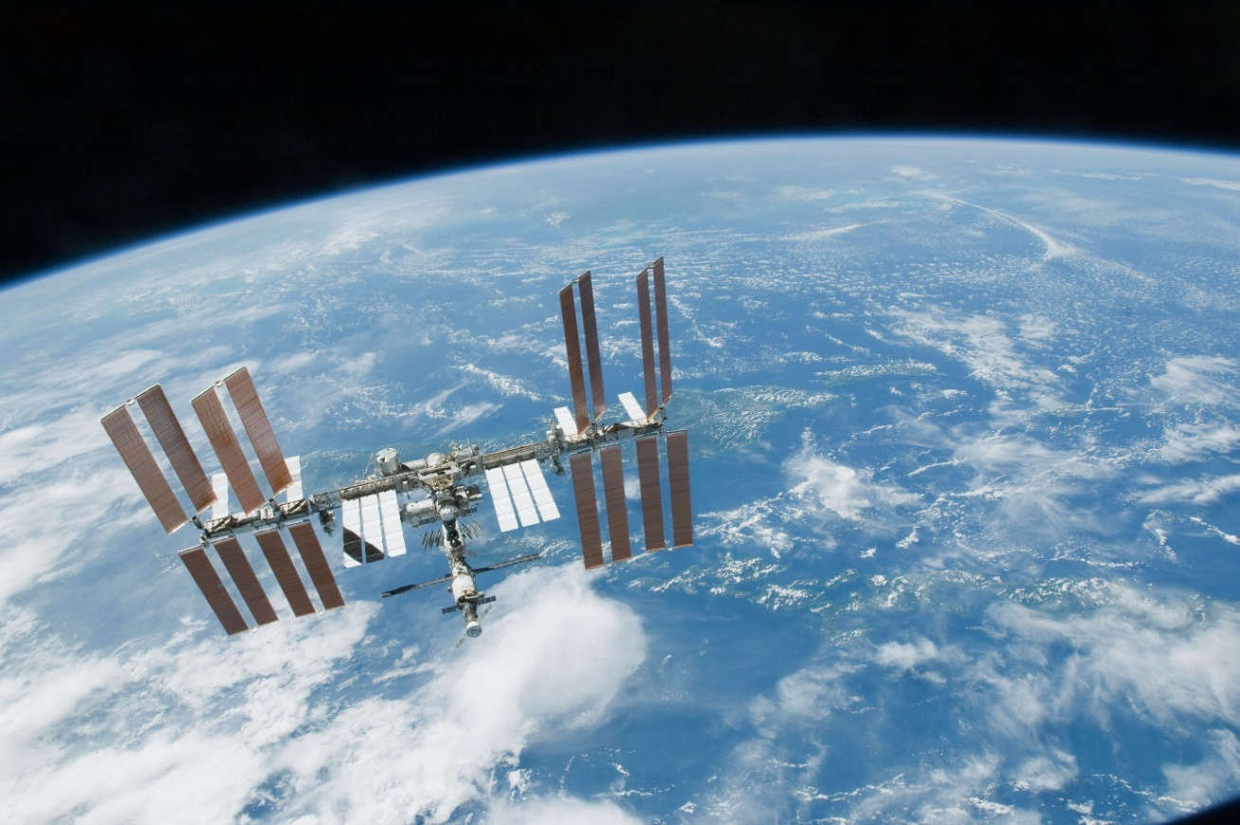

Source: NASA

For an observer watching on Earth, they will observe the ball taking some time $t$ to reach the end of the station where the space station is of length $l$.

The rest time between the two events $t_{0}$ (the ball being thrown and the ball reaching the other end) and the rest length between the two ends of the station $l_{0}$ will be affected by the relative velocity of the space station to an observer on earth[1]:

### Length Contraction – An Explanation from the Experts

See [Fermilab](https://www.youtube.com/channel/UCD5B6VoXv41fJ-IW8Wrhz9A)’s video on the topic. Fermilab is one of the biggest operating particle accelerator labs in the world and their physicists are experts in many fields, including relativity. The explanation that they go into is perhaps a little more depth than is required for HSC, but still worth the watch.

<https://www.youtube.com/watch?v=-Poz_95_0RA>

[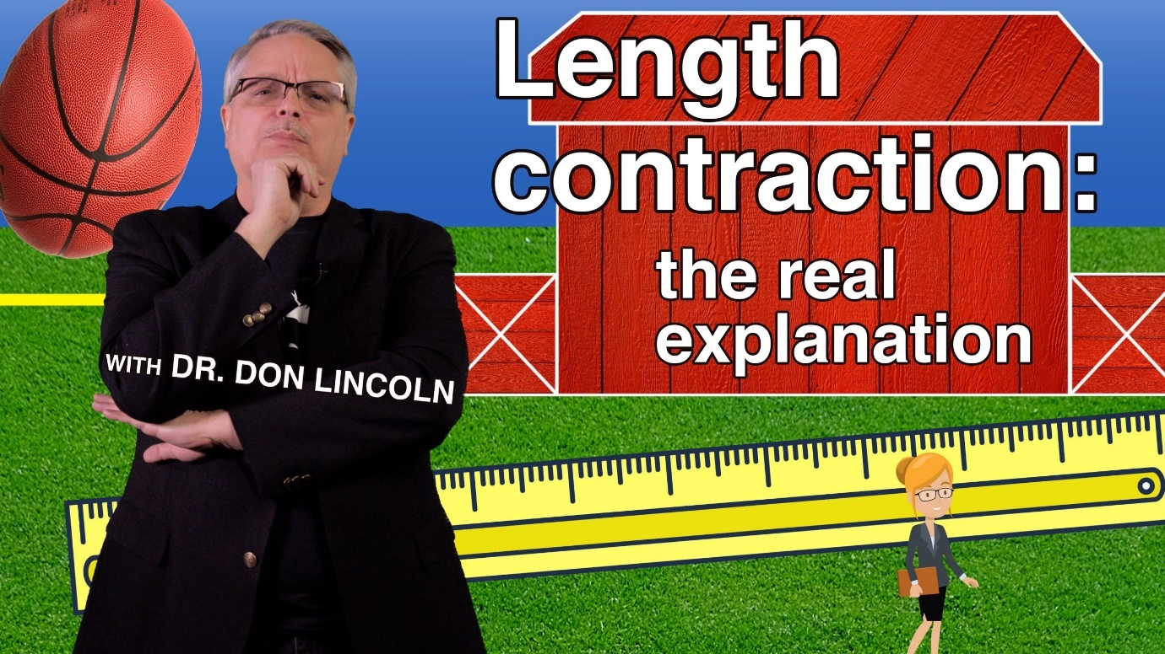](https://www.youtube.com/watch?v=-Poz_95_0RA)

### Time Dilation

‘A moving clock runs slow’

In the ball on the space station scenario, the time measured for the ball to reach the end of the space station will be shorter for the observer on the space station compared to the time measured by an observer on Earth. Alternatively, the observer on Earth will observe a longer time taken for a single event compared to the stationary observer.

#### Why does Time Dilation Occur? – The Photon Clock

Consider a situation where Jack is onboard a train moving at some fraction of the speed of light $β$, and Jill is beside the tracks on a platform. Inside the train is an evacuated vertical tube with mirrors on either end (at the top and bottom). Inside the tube is a single photon which bounces back and forth between the mirrors.

Let the distance between the two mirrors be $d$ and the time taken for the light to travel from the bottom mirror to the top mirror be $t$. As a result, $c=\frac{d}{t}$

From now on the bottom mirror shall be *Mirror A* and the top mirror is *Mirror B*. Therefore: the photon leaving Mirror A is *Event A* and the photon striking Mirror B is *Event B*.

Now we consider this from Jill’s perspective on the platform. While in Jack’s perspective Event A and B occur at the same horizontal coordinate, in Jill’s perspective they occur at different horizontal locations.

Jack

Jill

Jack

Jill

$$d=ct$$

$$ct$$

$$ct'$$

As can be seen in the diagram above, both Jack and Jill will observe events A and B and the distance the photon convers is $speed*time$. Since Jill observes the photon travelling a longer distance and $c$ is constant in both reference frames, Jills time ($t'$) must be longer than Jacks. In other words, Jill’s clock ticks faster than Jacks.

To calculate this by completing Jill’s diagram, using the speed of the train to calculate the horizontal distance. ($v_{train}=βc$)

Jill

$$ct$$

$$ct'$$

$$v_{train}t'$$

$${\left(ct^{'}\right)}^{2}={\left(ct\right)}^{2}+{\left(vt^{'}\right)}^{2}$$

$${\left(ct^{'}\right)}^{2}-{\left(vt^{'}\right)}^{2}={\left(ct\right)}^{2}$$

$$c^{2}t^{2}={\left(t^{'}\right)}^{2}\left(c^{2}-v^{2}\right)$$

$$t^{2}={\left(t^{'}\right)}^{2}\left(1-\frac{v^{2}}{c^{2}}\right)$$

$$t=t^{'}\sqrt{1-\frac{v^{2}}{c^{2}}}$$

$$t^{'}=\frac{t}{\sqrt{1-\frac{v^{2}}{c^{2}}}}=γt$$

Formula Sheet:

### Length Contraction

In the above scenario, the observer on Earth will observe the space station to be shorter along the axis of motion. This is because when an object moves relative to an observer, the space that object inhabits appears to shrink. In essence, all points along the direction of motion within that space get closer together.

For an observer in the moving space station, all objects in the universe appear to be moving relative to it and, therefore, will length contract. The distance between the space station and an object it is moving towards will appear to shrink and the Earth will seem thinner.

#### Why does Length Contraction Occur?

Consider a moving 1-metre ruler with some speed and an observer watching from some distance.

When the observer measures where the ends of the ruler are, the light rays take a different amount of time to reach the observer. The difference in time between the position measurements and the apparent simultaneity of them to the observer causes length contraction. (See length contraction derivation above).

$$v$$

### The Momentum Equation and the Universal Speed Limit

The equation for momentum (which can be derived from the Lorentz Transforms) is

$$p_{v}=γm_{0}v$$

Although it may seem like just an equation, the result of this equation is drastic.

$$γ=\frac{1}{\sqrt{1-\frac{v^{2}}{c^{2}}}}$$

As $v→c, γ→∞$

But when $v=c$

$$γ=\frac{1}{\sqrt{0}}$$

As a result, nothing in the universe with mass can travel at the speed of light as it would have undefined momentum.

### The Ladder Paradox

#### Setup

A farmer wants to fit his 20-metre ladder in his 10-metre shed. He knows that if his friend runs at some fraction $β$ of the speed of light he will observe the ladder as being length contracted to 10 metres, just short enough to fit into the shed.

But for his friend, the shed appears to be moving and will shrink from 10 metres to 5 metres long, while the ladder remains at 20 metres.

Who is right?

#### Explanation

They are both correct and both wrong. Length contraction of the ladder occurs due to the difference in the actual times at which the ends of the ladder are at their apparent positions. If we adjust for the time delay, the observers can both agree on where each end of the ladder was but must make their measurements at different times. If we do this, it can be made clearer how the observers disagree (but that’s hard so you’re just going to have to believe it).

The delay is important as it is the speed of information. The speed of information is typically the speed of light but in the ladder the speed of information is the speed of sound. So, when the ladder inevitably shatters on impact, the tail end won’t “know” that it needs to stop moving until the vibration (sound) has travelled to that end.

Similarly, when the farmer sees the front end of the ladder at one side of the shed, it has already moved past that end but the delay in the information leads him to believe that it is in the shed.

### The Twins Paradox

#### Setup

Two twins say goodbye to each other as one boards a large space rocket which will travel to a star 10 lightyears away and then travel back at a reasonable fraction of the speed of light. The twin remaining on Earth notes that since moving clocks run slow, the twin on Earth will have aged much more when they reunite, as the slowed clock of the twin on the rocket will mean they have aged more slowly during the trip.

The twin going on the trip counters this by noting that to them, the twin on Earth will appear to be moving and therefore it is the twin on Earth who will age more slowly.

Who is right?

To measure this, the travelling twin agrees to send a beam of light to Earth every time a year passes.

#### Explanation

The actual explanation for the time discrepancy is, in fact, acceleration and the effect it has by changing the reference frame of the traveller.

On the first half of the trip the light pulses are angled down on the diagram because they are travelling away from the twin. On the return they are angled up because they are travelling with the twin.  
When the travelling twin turns around, their velocity rapidly changes and so does their perception of time. This can be seen in the gap between the light pulses being strangely large at the point of acceleration.

Notice that when the twin is travelling with a uniform speed, the gap between years of the stationary twin is smaller than for the travelling twin (i.e. time runs slowly for them), meaning that time dilation is occurring as the twin predicted. However, there is a large gap where the twin turns around and this adds a large period of time where the travelling twin observes no time passing but the stationary twin ages by many years.

](https://www.youtube.com/watch?v=0iJZ_QGMLD0)For a more graphical explanation, see [minutephysics](https://www.youtube.com/channel/UCUHW94eEFW7hkUMVaZz4eDg)’ video on the paradox:

<https://www.youtube.com/watch?v=0iJZ_QGMLD0>

### Experimental Verification for Special Relativity

Special Relativity proves a very difficult topic to verify as one must travel at a significant fraction of the speed of light for its effects to be noticeable. As a result, a precise experiment was required, capable of measuring effects to fractions of a second.

#### The Hafele-Keating Experiment - 1972

One day Hafele (an assistance professor at the time) was sitting down writing notes on relativity when he did a ‘back of the envelope’ calculation showing that an atomic clock had enough precision to test the effects of Special and General relativity. He was unable to get the funding to do the test.

Eventually Hafele and Keating met after one of Keating’s lectures he was doing on astronomy. Keating had access to atomic clocks, and this was enough to get the pair $8000 dollars of funding, most of which went into plane tickets for the two and ‘Mr Clock’.

The experiment involved taking ‘Mr Clock’, who had been calibrated to his friend ‘Mrs Clock’ on the ground and shipping him on a long return trip plane ride. The disagreement between Mr and Mrs Clock was measured when they returned and was found to be exactly as Einstein predicted.

#### Muons from the Sun

Muons are Leptons from the standard model and are theoretically described by the associated quantum mechanics. The maximum time a muon should exist or the maximum distance it should be able to travel is given by Heisenberg’s uncertainty principle and can be shown to be too short for Muons from the sun to reach Earth. And yet we still detect them.

The reason for this can either be viewed as length contraction from the Muon’s perspective or time dilation from Earth’s perspective.

From the Muon’s perspective the distance between Earth and the Sun shrinks as it speeds up so at high enough velocities, the distance becomes shorter than the length given by the Heisenberg Uncertainty principle.

Similarly, from Earth’s perspective the Muon’s clock ticks more slowly so the time taken to reach Earth becomes shorter (for the Muon) to the point where it is shorter than the maximum lifetime of a muon.

#### Particle Accelerators

Particle accelerators provide similar evidence, with fast moving particles taking longer to decay than slower moving particles due to slower clocks.

There is also some much more complicated physics involved with conservation of momentum with the collisions that only works with the relativistic definition of momentum.

## Special Relativity Questions

### Question 1

Analyse and evaluate the evidence for Special Relativity.

### Answer 1

**Atmospheric Muons** – Muons are created when protons from space collide with atoms. The muons have a maximum lifetime on the order of ${10}^{-6} s$ (as predicted by Quantum physics), far too short to reach Earth by traditional physics.

From Earth’s perspective, relativistic time-dilation due to the muon’s motion relative to Earth extends the lifetime long enough for the muons to reach Earth’s surface.

From the muon’s perspective the relative motion of the Earth causes the distance between the upper atmosphere and the surface to be length contracted, allowing Earth to hit the muon.

Without these effects the muons could not be detected at Earth’s surface, therefore this confirms each of the relativistic effects.

**Hafele-Keating** – Hafele and Keating used atomic clocks to measure the effects of Special and General Relativity. The atomic clocks were originally synchronised with clocks on Earth and then taken on a plane flight. The discrepancy between the clocks after the trop was predicted exactly by relativity[2] (time dilation), confirming the theory’s predictions.

### Question 2

A space rat is travelling in (what it believes to be) its $1.0 m$ long rocket ship past one of Elon Musk’s cars in space, at a speed of $v=0.25c$, when it decides to jump. The time taken, from the rat’s perspective, for it to float to the top of the rocket is $0.50 s$.

From the car’s perspective, calculate the length of the rocket and the time taken for the rat to hit the top of the rocket.

### Answer 2

$$t_{car}=t_{rat}γ=\frac{t_{rat}}{\sqrt{1-\frac{v^{2}}{c^{2}}}}$$

$$v=0.25c ⇒ t_{car}=\frac{0.50s}{\sqrt{1-{0.25}^{2}}}$$

$$t_{car}≈0.52 s$$

$$l=\frac{l_{0}}{γ}=l_{0}\sqrt{1-\frac{v^{2}}{c^{2}}}$$

$$l=1 m×\sqrt{1-{0.25}^{2}}$$

$$l≈0.97 m$$

# Module 8 – From the Universe to the Atom

## Base Units

Mass ($m$) – Kilograms ($kg$)

Displacement ($\overset{⃑}{s}$) – Metres ($m$)

Time ($t$) – Seconds ($s$)

Speed ($v$) – Metres per second ( $ms^{-1}$**or $m/s$**)

Momentum ($p$) – Kilogram metres per second ( $kg ms^{-1}$**or $kg m/s$** )

Wavelength ($λ$) – Metres ($m$)

Frequency ($f$) – Hertz ( $Hz$**or $s^{-1}$** )

Energy ($E$) – Joules ($J$**or $kg m^{2} s^{-2}$**  )

Luminosity ($L$) – Power ($J s^{-1}$)

Intensity ($I$) – Power per area ( $J m^{-2} s^{-1}$**or $kg s^{-3}$**  )

Angular Momentum ($L$) – Kilogram square-metres per second ($kg m^{2} s^{-1}$)

## Constants

The Speed of Light $c=3.00×{10}^{8} m s^{-1}$  
Planck Constant $h=6.626×{10}^{-34} kg m^{2} s^{-1}$

Rydberg Constant (Hydrogen) $R=1.097×{10}^{7} m^{-1}$

Wein’s Displacement Constant $b=2.898×{10}^{-3} m K$

## Equations

$$λ=\frac{h}{p}=\frac{h}{mv}$$

*The de Broglie wavelength of an object with mass.*

$$\frac{1}{λ}=R\left(\frac{1}{{n_{f}}^{2}}-\frac{1}{{n_{i}}^{2}}\right)$$

*Rydberg equation for the wavelength of a photon ejected or absorbed by a hydrogen atom.*

*The rest energy of an object with mass.*

$$E=mc^{2}$$

$$N_{t}=N_{0}{\left(\frac{1}{2}\right)}^{\frac{t}{t_{0.5}}}=N_{0}e^{-λt}$$

$$λ=\frac{\log_{e}{2}}{t_{0.5}}$$

*The Nuclear decay equations.*

$$ℏ=\frac{h}{2π}$$

*Another notation/form of the Plank Constant (it shows up a lot).*

$$L=mr^{2}ω=mvr=\frac{nh}{2π}$$

$$mvr=nℏ, ℏ=\frac{h}{2π}$$

*Bohr’s postulate that Angular Momentum is quantised.*

## Course Notes

### Models of The Atom

#### Dalton – 1808

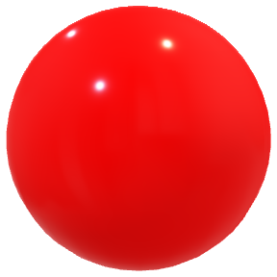Dalton expanded on the model proposed by the Greeks where he hypothesised that the Atom was made of a solid ‘billiard ball’ and was uncuttable. He explained different elements by proposing that each element had its own ball.

#### Thomson – 1904

Thomson experimented with cathode ray tubes from different materials, using electric and magnetic fields to determine its properties:

* The ray was negatively charged
* The thing which made up the ray could be forced out of any material

He was also able to balance the effects of the electric and magnetic fields to determine their charge to mass ratio but was unable to calculate either separately. In doing so he determined that the ray was made of small particles with some mass and charge.

From this he developed the ‘Plumb Pudding’ model which was an amendment to the Dalton model, with each atom being made of a different positively charged ball structure of uniform charge distribution and with negatively charged particles (electrons) distributed randomly throughout.

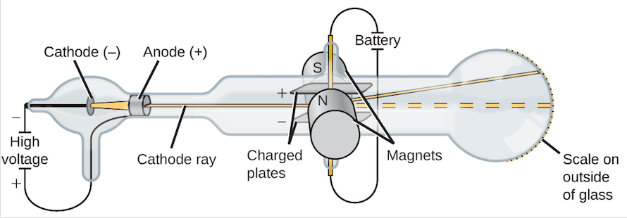

Source: Openstax

##### The Cathode Ray Experiment

The cathode ray experiment allowed the properties of what is now known as the electron to be deduced. The first setup involved:

* an electron gun (parallel plates with a hole for the accelerated electrons to pass through).
* Electric and Magnetic fields setup so they oppose and equal each other aka. a velocity selector: so named because $qvB=qE⇒v=\frac{E}{B}$

From this he deduced the velocity of the particles.

The next setup involved just using

* A magnetic field
* A detection plate

This allowed the radius of curvature given by $qvB=\frac{mv^{2}}{r}$ to be found. This allowed for the rearrangement of the above equation, using the velocity from the previous setup:

$$\frac{q}{m}=\frac{v}{Br}$$

$$=\frac{E}{B^{2}r}$$

#### Millikan Oil Drop Experiment – 1909

The oil drop experiment allowed for the determination of the charge of the electron.

Since the density $ρ$ of the oil was known, the equation $m=Vρ$ where $V$ is volume could be used to determine a given drop’s mass. When drops were injected into the apparatus, they formed spheres and since the volume of a sphere is given by $V=\frac{4}{3}πr^{3}$ and the radius of a given drop could be measured, the mass of a drop could be experimentally derived.

Millikan established an electric field such that it opposed gravity and used the equivalence of the forces and the known mass to find the charge of each drop:

$$qE=mg$$

$$q=\frac{mg}{E}$$

Millikan then noticed that the charge of each drop was always an integer multiple of $1.602×{10}^{-19}$ and noted that this must be the fundamental charge unit or the electron’s charge.

#### Rutherford – 1911

Rutherford discovered, with the gold foil experiment (Geiger-Marsden), that the atom is made of mostly empty space but has a centre with an extreme density of positive charge (a nucleus). This was concluded from the fact that most of the alpha particles passed straight through the atoms, some were deflected slightly, and a few were deflected back in the direction they came from.

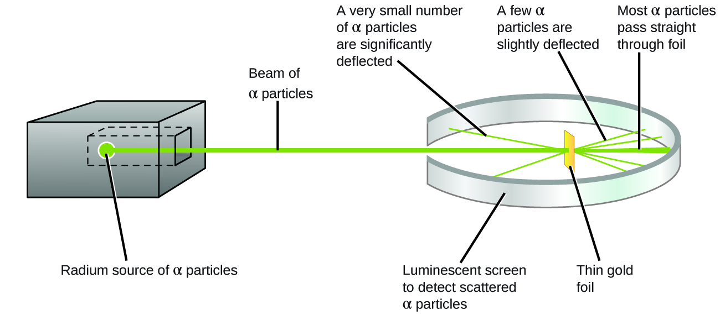

Source: Openstax

The fact that most particles went straight through meant that they did not come near another positive charge and experienced nearly no force. However, the fact that ones that did get deflected got deflected by a large amount implied a large charge density where the alpha particle travelled (and a large force).

#### Bohr – 1913

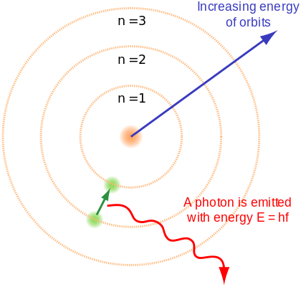Bohr noted that, by Maxwell’s equations, a charge in circular motion was accelerating and would therefore create light. This light should therefore be proportional to the acceleration and would cause the electron to fall into the nucleus emitting a smooth spectrum of light. **Neither of these occur.**

Bohr then went on to develop his quantised orbital theory of electron orbits where the electrons orbited at set radii and would ‘jump’ or ‘fall’ between them. To go along with this, he formalised 3 postulates:

1. Electrons orbit around a nucleus with a high density of positive charge per volume with centripetal acceleration from the coulomb force: $\frac{1}{4πε_{0}}\frac{q_{1}q_{2}}{r^{2}}=\frac{mv^{2}}{r}$
2. Electrons orbit in a quantised number of orbitals where the angular momentum of the electrons exists in quantised states with $L=mr^{2}ω=mvr=\frac{nh}{2π}$ where $n$ is the integer orbit.
3. While in these orbits the electrons are in a ‘stationary state’, meaning they will not lose a small amount of energy as a photon and fall to some radius between the orbits.

#### Theorisation of the Proton and Neutron – 1920s

Throughout the 1920s it was discovered that the mass of atoms was approximately integer multiples of the mass of the Hydrogen nucleus and that the atomic number was proportional to the charge on the nucleus. This knowledge, combined with the discovery of isotopes (atoms with different masses but the same atomic number), led to the theorisation of the Proton and Neutron (believed to have the same mass).

#### De Broglie – 1924

He explained Bohr’s model by proposing that the electron could be a wave and a particle (invoking Einstein’s wave-particle duality theory). De Broglie postulated that if the electron were a wave then it would reason that it would have an integer number of wavelengths. This explained why the electron only existed at certain radii, as these were the radii where the electron could inhabit an orbit where the circumference is an integer multiple of the wavelength.

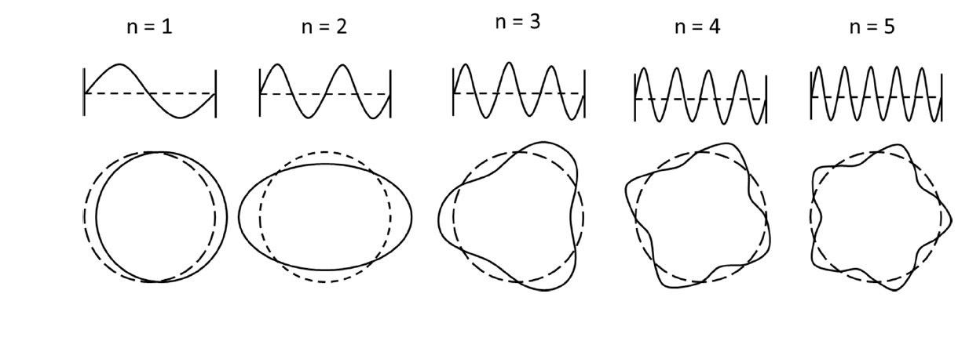

See <https://www.desmos.com/calculator/xww8n1r3kt> for a de Broglie wave generator.

#### Schrödinger – 1926

Schrödinger took de Broglie’s proposed wave theory and generalised it for all fundamental particles (particles which exhibit wave properties). He invented the wave function which stores all properties about that particle including its position, momentum, energy etc. This wave function however represents the probabilities of each of these properties being a certain value, not the values themselves.

Schrodinger’s Wave Equation is written in general form, where $Ψ$ is the wave function:

$$-\frac{ℏ^{2}}{2m}∇^{2}Ψ+VΨ=iℏ\frac{∂Ψ}{∂t}$$

$V$ is the sum of all potentials on the particle (has units of energy) $m$ is its mass, $∇^{2}$ is the Laplacian, $ℏ=\frac{h}{2π}$ and $i^{2}=-1$

This theory is currently the accepted theory of subatomic particles.

##### But isn’t wave motion accelerated motion?

Yes, wave oscillation is a form of acceleration. It wasn’t until a year or so after Schrödinger published his equation that people began to realise that the thing doing the ‘waving’ was in fact probabilities, not the particle. As such, Bohr’s ‘stationary state’ idea is correct (just not in the way he thought).

#### Chadwick – 1932

He found the first experimental evidence for the Neutron (in essence he discovered it, though he did not theorise it).

Neutrons had been theorised for a long time and theoretical physicists had just kind of accepted they existed. They provided a great explanation for why the mass of particles on the periodic table increased at a greater rate than their charge.

##### The Neutron Experiment

Alpha particles were emitted onto a Beryllium plate. A sheet of paraffin wax was then placed after the Beryllium and a charge detector detected what were found to be protons being emitted from the wax. However, the charge detector did not detect anything when placed between the beryllium and wax.

By putting a thick lead plate between the beryllium and the wax, the release of protons from the wax was stopped. Using this, Chadwick reasoned that there must be some neutral charge being emitted from the beryllium.

Using conservation of mass and momentum, Chadwick determined the ratio of the neutral particles mass to the proton and found that the masses were almost identical (the neutral particle was just 0.1% heavier). This allowed Chadwick to conclude that he had found the theorised Neutron.

$$α$$

$$Be$$

$$Wax$$

$$Charge \\ Detector$$

$$Pb$$

$$Nuetron$$

$$Proton$$

### Emission Spectrum of Hydrogen and the Balmer Series

The Balmer series is a specific set of emission lines which occur in Hydrogen atoms due to the movement of electrons from shell 2 to shells 3, 4, …

Though there are many other series associated with the movement of electrons from the first shell up and the third shell etc. the Balmer series is within the visible spectrum and can be directly observed, while the others are in invisible areas of the spectrum.

The wavelength of the light produced by a transition of an electron is given by the Rydberg equation.

$$\frac{1}{λ}=R\left(\frac{1}{n_{f}^{2}}-\frac{1}{n_{i}^{2}}\right)$$

For the Balmer series $n_{i}=2$ (or if a photon is absorbed then $n_{f}=2$).

### The Standard Model

#### Terminology

**Quark** – A particle which, among other properties, possesses a colour charge (red, green or blue). As a result, they interact with Gluons and are affected by the strong interaction.

**Lepton** – A particle which does not interact via the strong interaction (i.e. it has no colour charge)

**Boson** – A particle responsible for force interactions.

**Virtual Particle** – A particle which is not directly observable but can still interact with other particles.

**Hadrons** – Particles made of two or more quarks with integer charges.

**Baryons** – Particles made of three quarks

**Anti**-**Matter** – A particle which is the complete opposite of another (opposite electric charge, opposite colour charge etc.)

**Annihilation** – Occurs when a particle collides with its anti-particle. The process creates an immense amount of energy in the form of photons.

**Fundamental Forces** – The minimum number of forces required to describe all phenomena in the universe (Strong, Weak, Electromagnetic, Gravity)

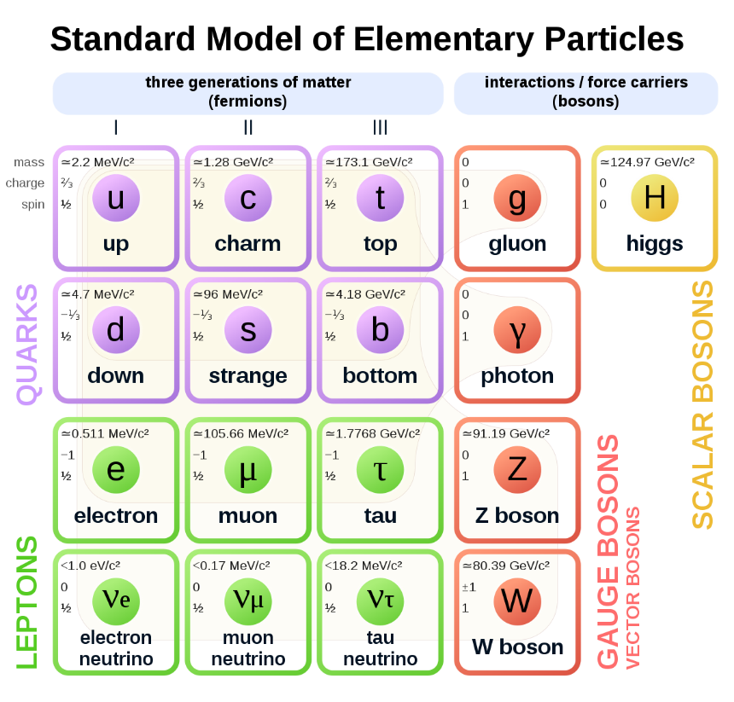

#### What is the Standard Model?

The standard model is the current model of particle physics which has been experimentally verified.

The standard model consists of fundamental particles with certain properties such as charge, mass etc.

Each of these fundamental particles is a little wiggle (wave) in its respective field (e.g. the electron is a small disturbance in the electron field). The reason particles have certain properties is a function of how much one field affects another field.

#### Anti-Particles

Anti-particles such as the anti-electron (positron) come up a lot in quantum physics. Although they have been observed in experiment, they were first predicted by Dirac when he was formulating his equation for the electron, where he found his equations always had two solutions. His two solutions consisted of opposite energies and opposite charges and he interpreted this as being a particle and its anti-particle.

Although the maths he performed was a little more complex, a basic understanding of this can be gleaned from the energy equation:

$$E^{2}={m_{0}}^{2}c^{4}+p^{2}c^{2}$$

If we assume the velocity and momentum are zero, we find $E^{2}=m^{2}c^{4}$

This does not rearrange to $E=mc^{2}$, rather it rearranges to $E=±mc^{2}$ and the negative solution is what Dirac interpreted as the anti-particle.

#### What does $E=mc^{2}$ mean?

When Einstein wrote his paper, he showed that due to special relativity an object which loses some kinetic energy $E$ lost mass $Δm=\frac{ΔE}{c^{2}}$

Although it is written as $E=mc^{2}$ it should actually written $m=\frac{E}{c^{2}}$  
What this shows is that mass is actually just a way we measure the net energy content of an object. The inherent mass an object has actually comes from the energy the Higgs field gives the particles it is made of. Furthermore, mass is not a real property, rather it is a manifestation of energy and is how we measure it.

Go watch this video for a good explanation:

[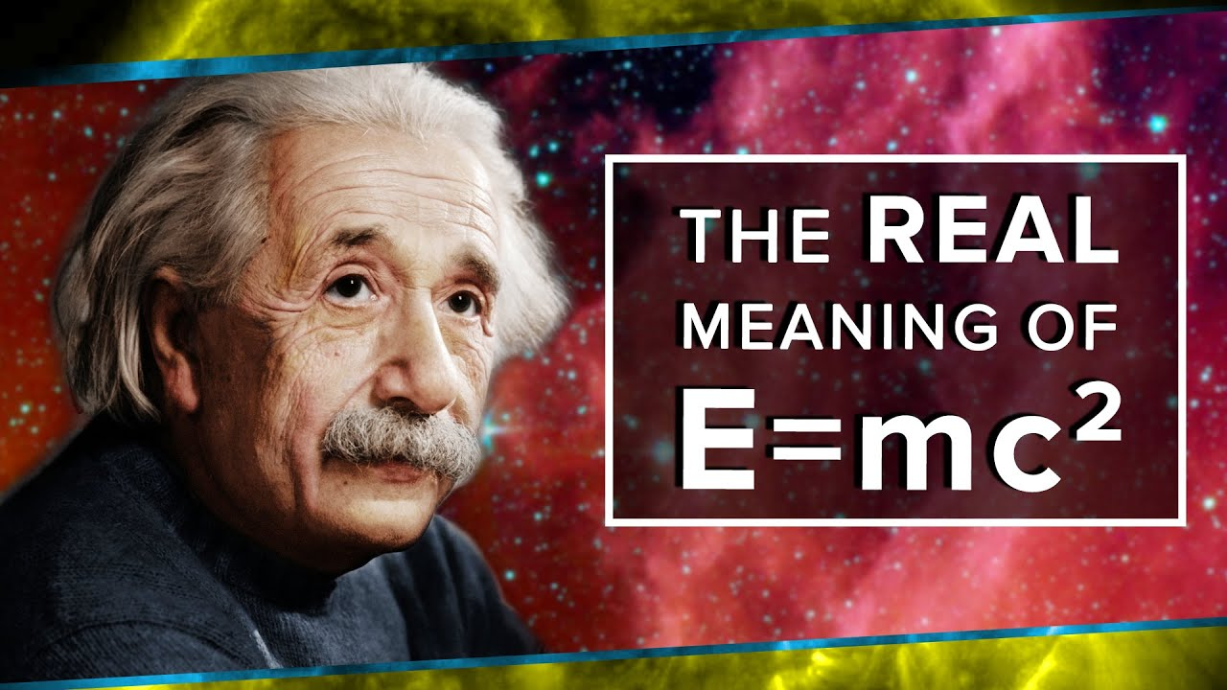](https://youtu.be/Xo232kyTsO0)

<https://youtu.be/Xo232kyTsO0>

#### Conservation Laws

All conservation laws are due to invariances in some value. Where there is an invariance in some value during an interaction, some value is conserved (some are given below).

###### Conservation of Charge

In any interaction where there is Gauge symmetry, the total charge of the universe must be conserved where:

$$\left(+1\right)+\left(-1\right)=0$$

###### Conservation of Colour

In any interaction, the total colour charge must be conserved where:

$$\left(B\right)+\left(G\right)+\left(R\right)=0$$

$$\left(B\right)+\left(\overline{B}\right)=0$$

###### Conservation of Momentum

In all interactions where there is translational symmetry (location of the event occurred does not change the interaction between the particles), momentum must be conserved.

###### Conservation of Angular Momentum (Spin)

In all interactions where there is rotational symmetry (the event would be the same if space were rotated), intrinsic angular momentum is conserved.

###### Conservation of Lepton Number

This is empirical and has never not been observed. This is an additive law where normal leptons such as electrons $\left(e^{-}\right)$ and electron neutrinos $\left(ν_{e}\right)$ have $+1$ lepton number and their anti-particles such as the positron $\left(e^{+}\right)$ and anti-neutrino $\left({\overline{ν}}_{e}\right)$ have a lepton number of $-1$.

#### The LHC and other Evidence for the Standard Model

The LHC collides protons and other Hadrons together at very high speeds $\left(0.999c\right)$.

The protons slam together at such high energies that they break apart and their constituent particles decay into lower energy particles.

The particles produced are random (to an extent) so they slam protons together many millions of times per second. They produce too much data to store so most of it is thrown out and only the possibly interesting ones are stored.

The detectors at the LHC are able to detect certain types of particles depending on the detector (there are 4 main detectors). The detected particles and their energies can then be used to reverse engineer the collision which occurred, and it has been shown that the collisions match what would be expected from protons made of three quarks colliding.

#### Quarks, Gluons & Colour Charge

Gluons and Quarks possess a property called colour charge (it is not colourful but there are three types instead of two so physicists needed something more than $+ -$) the colours are Red, Green and Blue (with a corresponding Anti-Red, Anti-Green and Anti-Blue for anti-particles). The charges are named as such since red + green + blue = white, so the charges cancel in sets of three. The study of these charges and the corresponding interactions is called Quantum Chromodynamics.

The ‘flavour’ of a quark is its classification (i.e. Up, Down, Charm, Strange etc.).

Though Quarks possess electric charge, the primary force which bonds them is mediated by their colour charge and the force particle corresponding to it: the gluon.

The gluon has no mass or electric charge, but it does have a colour charge and an anti-colour charge (never the same like blue and anti-blue though) and so it is one of the few particles which can interact with quarks without interacting with other particles.

Quarks are held together by flux tubes of gluons which attract the quarks together. The main property of these flux tubes that differs from lone gluons is that the colour charge of the gluons in the flux tubes cancel to be zero, keeping the net colour charge of the proton and neutron zero.

The analogy of springs is used for the flux tubes since the attractive force created by the gluons increases with the distance of the particles as with a spring.

### Nuclear Physics

#### Terminology

**Bonding Energy** – The potential energy in the bond such that:

$$E_{bond}=-U$$

$$F_{bond}=-∇U≈-\frac{ΔU}{Δr}$$

**Atomic Mass Unit $\left(u\right)$**  – The average mass of the nucleons in a Carbon 12 nucleus such that:

$$u=\frac{m_{C-12}}{12}$$

**Decay** – The process by which one particle becomes another particle by emitting another particle.

**Nucleon** – A proton or neutron.

**Half Life** – The time a sample of some material takes to transmute into another material.

**Control Rod** – A material used to absorb neutrons in a nuclear reaction.

**LHC** – The Large Hadron Collider located under Switzerland and run by CERN.

#### Decay

Nuclear decay is a random (but statistically predictable) process whereby energetically unstable nuclei decay into more stable nuclei and release certain particles such that:

* Charge is conserved
* Energy is conserved
$U+E_{K}$

* Momentum is conserved

##### Alpha $\left(α\right)$ Decay

Alpha decay is a result of the strong force between neighbouring nucleons being weaker than the electrostatic repulsion of the protons. The exact mechanism is hard to explain but fundamentally it is when the potential energy binding an alpha particle $\left(α or {}_{2}^{4}{He}\right)$ to the nucleus is near zero. There is still a large potential bond between neighbouring nucleons (due to the strong interaction) however the chunk is only loosely held so it is ejected.

The leftover potential energy is lost as a photon and can be measured as a loss in mass.

The nuclear equation can be written as:

$${}_{Z}^{A}X→{}_{Z-2}^{A-4}Y+{}_{2}^{4}{He}+{}_{0}^{0}γ$$

Or

$${}_{Z}^{A}X→{}_{Z-2}^{A-4}Y+{}_{2}^{4}α+{}_{0}^{0}γ$$

##### Beta $\left(β\right)$ Decay

Beta decay occurs in two forms

$β^{-}$

$β^{+}$

$β^{-}$ decay is where a neutron becomes a proton through the weak interaction and, by conservation of charge, an electron is released. During this process, an anti-neutrino is also given off.

$${}_{Z}^{A}X→{}_{Z+1}^{A}Y+{}_{-1}^{0}{e^{-}}+{}_{0}^{0}{{\overline{ν}}_{e}}+{}_{0}^{0}γ$$

$β^{+}$ decay is where a proton becomes a neutron through the weak interaction and, by conservation of charge, a positron is released. During this process, a neutrino is also given off.

$${}_{Z}^{A}X→{}_{Z-1}^{A}Y+{}_{1}^{0}{e^{-}}+{}_{0}^{0}{ν_{e}}+{}_{0}^{0}γ$$

The potential energy lost by this transmutation is the emitted as a photon.

###### Why neutrinos are emitted

Neutrinos are emitted in these interactions to conserve spin and lepton number. The neutrino conserves spin because it spins the opposite way to the electron (is spin down if the electron is spin up) making the net spin zero.

Neutrinos and electrons have lepton numbers of $+1$ while anti-neutrinos and positrons have lepton numbers of $-1$. The total sum of the products must equal the initial (which was zero).

##### Gamma $\left(γ\right)$ Emission

Gamma emission is the emission of a photon (typically in the gamma spectrum but could be in any spectrum) and occurs due to a loss of potential energy (also known as an increase in binding energy_ inside the nucleus. This can occur during any type of radioactive decay and is a result of protons and neutrons swapping places inside the nucleus (a process which is made possible due to the nuclear force interaction).   
When the protons move, they move in the direction such that their potential energy decreases. So, by conservation of energy, this energy must be regained. In this case it occurs as a photon.

This can occur during all types of radioactive decay but typically occurs during $β$ decay.

#### Penetrating Distance and Ionisation

Different forms of radiation are able to penetrate materials to varying distances. Generally, the further radiation can penetrate, the lower its ionisation potential. This is not true when comparing gamma radiation to X-rays as gamma rays possess both a greater penetration distance and ionisation energy.

$α$ particles are most likely to cause ionisation as they strongly attract electrons that they are near to.

$β^{-}$ (electrons) cause ionisation because they collide with the electrons in outer shells of atoms, transferring momentum and knocking the electron off.

$β^{+}$ (positrons) cause ionisation because they annihilate electrons in a collision.

$γ$ rays have much greater energies ($E=hf$) than is required to ionise an atom and so, on collision with an electron, transfer their energy to the electron as kinetic energy, ionising the atom.

#### Half Life

Half Life describes the statistical nature of nuclear decay in one easy concept. All unstable nuclei (prone to either form of decay) will have some time after which half of a large sample will have decayed.

Since after every integer multiple of the half life time $\left(t_{0.5}\right)$ the sample has halved in size, we can write that mathematically where $N_{t}$ is the amount after some time and $N_{0}$ is the original amount:

$$N_{t}=N_{0}{\left(\frac{1}{2}\right)}^{\frac{t}{t_{0.5}}}$$

It is easy to see when $t=t_{0.5}, N_{t}=\frac{N_{0}}{2}$ and when $t=2t_{0.5}, N_{t}=\frac{N_{0}}{4}$ etc.

Now we rearrange because the formula sheet is unnecessarily specific…

$$N_{t}=N_{0}e^{\ln\left({\left(\frac{1}{2}\right)}^{\frac{t}{t_{0.5}}}\right)}$$

$$N_{t}=N_{0}e^{\frac{t}{t_{0.5}} \ln\left(\frac{1}{2}\right)}$$

$$N_{t}=N_{0}e^{\frac{-t}{t_{0.5}} \ln\left(2\right)}$$

$$N_{t}=N_{0}e^{-t \frac{\ln\left(2\right)}{t_{0.5}} }$$

Now we let $\frac{\ln\left(2\right)}{t_{0.5}}=λ$

$$N_{t}=N_{0}e^{-λt }$$

$$λ=\frac{\ln\left(2\right)}{t_{0.5}}$$

#### Fission

Fission is the process by which a nucleus is split into two smaller parts. Typically, this is done with heavy nuclei such as Uranium-235 $\left({}_{92}^{235}U\right)$ whereby the atom is made unstable by shooting low velocity neutrons at it and it splits into two parts, one a little heavier than the other. As a result of this, neutrons are also released. E.g.

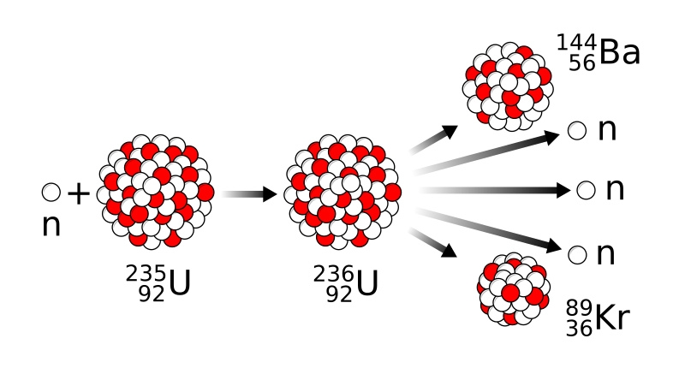

Source: MikeRun

$${}_{0}^{1}n+{}_{92}^{235}U→{}_{36}^{89}{Kr}+{}_{56}^{144}{Ba}+3{}_{0}^{1}n$$

A nuclear reaction such as that in a bomb occurs when more neutrons are produced per second than reactions are occurring (i.e. more than one neutron is produced per fission on average), this is a runaway reaction.

A nuclear reaction such as ones used in nuclear reactors is one where the number of neutrons produced per reaction is less than or approximately one, so it is ‘controlled’.

##### The Moderator

This is made of a material with a slightly higher mass than the neutron such as Hydrogen $\left({}_{1}^{1}H\right)$, Deuterium $\left({}_{1}^{2}H\right)$ or Tritium $\left({}_{1}^{3}H\right)$. The neutrons collide with these atoms and share their energy. This slows down the neutron so that it can be absorbed for more reactions.

##### Control Rods

If a reaction such as one in a nuclear reactor begins producing more neutrons than desired, control rods are inserted. Control rods are made of materials such as boron which more freely absorb neutrons (known as neutron poisons).

##### Enrichment

Since Uranium-235 is one of the few very reactive substances for nuclear reactions, it often needs to be separated out from the less reactive Uranium isotopes if a faster reaction is desired (the concentration of Uranium-235 required for a nuclear bomb is around 97%). Other Uranium isotopes can even absorb neutrons without reacting as they are more stable.

#### Fusion

Fusion is the process by which protons and neutrons are brought together with enough energy that they overcome their electric repulsion and are able to bond via the strong force. In the sun this is done by the pressure of gravity (and with a little help from quantum tunnelling) and in fusion reactors it occurs by colliding particles with enough kinetic energy that they bond but not so much that they obliterate each other.

Below is a graph of overall binding energies of nuclei.

##### Getting Energy from Fusion

Remembering that in actuality, the bonding energy is the negative potential energy, an increase in bonding energy is a net decrease in energy:

As atoms before iron are bonded, the net energy inside the nucleus decreases. By conservation of energy, an equivalent amount of energy must be released. The released energy is given by $E=-∆U$ (the change in energy between the particles). If $E$ is negative, then extra energy is needed to bond them.

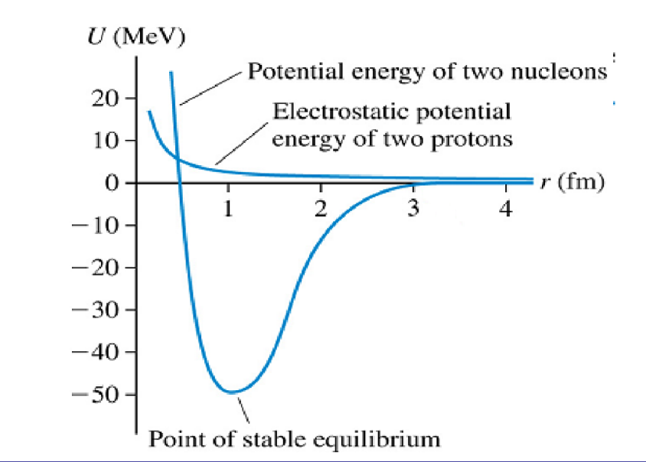

The attractive strong force appears at close ranges and makes the potential energy negative while the electric potential remains positive.

##### Forces, Energies and Emitted Particles

As a general rule, attractive forces produce negative potentials and repulsive forces produce positive potentials. When the net energy between particles decreases (bonding energy increases) there has been an increase in strength of the attractive force and vice versa.

When the energy between two quantum particles decreases, the energy must be emitted. The energy is often emitted as a photon. Sometimes, a particle can acquire a lower energy state (greater attractive force) by transmuting into another particle (like proton to neutron) and if this occurs, conservation of charge dictates that the equivalent charge must be emitted. Therefore, a positron and anti-neutrino will be released in such process such that they carry away the energy and charge.

##### Mass Defect in Stars

It is often said that stars lose mass when they fuse matter, and that this mass is lost as energy is the form of photons. This is not entirely correct; it is more accurate to say that when we measure mass, we are measuring the net energy content of stars. So, when stars lose energy, their observed mass drops but the particles which make it up do not lose mass, we are just observing the loss of energy in a strange way.

Really, we are saying that $m=\frac{E}{c^{2}}$ and as $E$ decreases, the apparent mass decreases.

##### Fusion Inside a Star – Hydrogen to Helium and the CNO Cycle

###### Proton-Proton Fusion – 26.73 MeV

Here’s how helium can be made in the sun from 4 protons.

$${}_{1}^{1}H+{}_{1}^{1}H→{}_{1}^{2}H+{}_{1}^{0}{e^{+}}+{}_{0}^{0}{ν_{e}}$$

$${}_{1}^{2}H+{}_{1}^{1}H→{}_{2}^{3}{He}+{}_{0}^{0}γ$$

$${}_{2}^{3}{He}+{}_{2}^{3}{He}→{}_{2}^{4}{He}+2{}_{1}^{1}H$$

###### The CNO Cycle – 25 MeV

The CNO cycle is another way that stars take 4 protons and make a helium nucleus.

$${}_{6}^{12}C+{}_{1}^{1}H→{}_{7}^{13}N+{}_{0}^{0}γ$$

$${}_{7}^{13}N→{}_{6}^{13}C+{}_{1}^{0}{e^{+}}+{}_{0}^{0}{ν_{e}}$$

$${}_{6}^{13}C+{}_{1}^{1}H→{}_{7}^{14}N+{}_{0}^{0}γ$$

$${}_{7}^{14}N+{}_{1}^{1}H→{}_{8}^{15}O+{}_{0}^{0}γ$$

$${}_{8}^{15}O→{}_{7}^{15}N+{}_{1}^{0}{e^{+}}+{}_{0}^{0}{ν_{e}}$$

$${}_{7}^{15}N+{}_{1}^{1}H→{}_{6}^{12}C+{}_{2}^{4}{He}$$

###### Triple Alpha Fusion – 7.725 MeV

Triple $α$ fusion occurs in old, post main series stars.

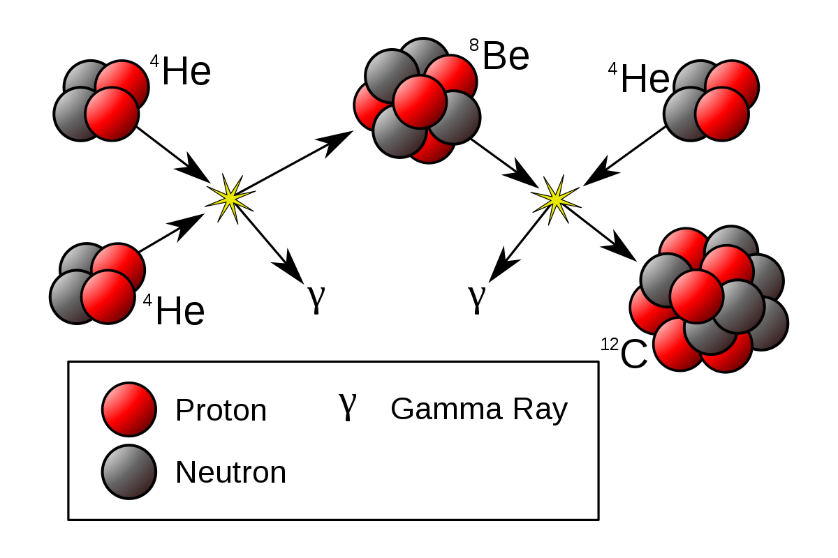 ${}_{2}^{4}{He}+{}_{2}^{4}{He}→{}_{4}^{8}{Be}+{}_{0}^{0}γ$

$${}_{4}^{8}{Be}+{}_{2}^{4}{He}→{}_{6}^{12}C+{}_{0}^{0}γ$$

#### Spectral Classes

Different stars fuse different types of nuclei and, as a result, have certain properties.

PP Chain gives the most energy per reaction but requires a greater amount of gravitational attraction which can only be achieved after the star has made heavier elements. As a result, small stars fuse using PP chain and then hotter stars fuse lots of nuclei using CNO as it is easier to do (particles have more mass so easier to get high momentum collisions).

Big stars with lots of mass and not as much fuel burn using triple $α$.

#### Star spectra and what it says about a star

Stars emit light due to Blackbody radiation at their surface. Stars generate the energy to heat up the surface through fusion, however fusion itself does not create light.

The blackbody spectrum is continuous, with a peak in the spectrum occurring at $λ_{max}=\frac{b}{T}$. Gaps appear in the spectrum due to the atoms in the upper atmosphere of the star which absorb photons which hit them at certain wavelengths. The atoms then re-emit this energy as photons (not necessarily the same photon) but in a random direction. The result is that light of the wavelengths where it can be absorbed by the atmosphere of the star are much dimmer than the rest of the blackbody spectrum of the star. This is the star’s absorption spectra.

##### What can it the absorption spectra tell us?

###### Temperature

The brightest part of the spectrum tells us the temperature.

###### Atmospheric Elements

By comparing the shape and position of the spectral lines to known elements on Earth, we can determine what elements are in the atmosphere of the star (it is rare that elements have the same absorption line, so it is easy to guess and check elements).

###### Density

The density of the star’s atmosphere is a result of the star’s density because more dense stars have a greater gravitational attraction and therefore hold a denser atmosphere. A denser atmosphere will result in darker absorption lines (more stuff to absorb photons).

###### Rotational and Translational Velocity

The velocity of points on a star will result in a Doppler effect. If a star is rotating, one side of the star will redshift the spectrum and one will blueshift it. This can be measured and used to calculate the rotational velocity.

Translational velocity is similar but instead we compare the theoretical colour of the star based on its temperature to its apparent colour (still a Doppler effect).

### The Big Bang and the Origins of the Elements

The Big Bang theory originates from General Relativity, where the solution to Einstein’s equations shows that the universe must have a beginning.

The Big Bang Theory is the currently accepted theory that the universe began as infinitesimal point and expanded from that point. The theory describes the very expansion of space itself, that is if space is made of 4 dimensions $\left(x, y, z, ct\right)$ then these dimensions are what expanded.

This early universe was very dense in energy and so matter was able to spring out of the energy of the vacuum in the form particle anti-particle pairs. Initially, the temperature of the universe was very great, so the particles were moving too fast to combine and quickly collided with their respective anti-particles.   
It is measurable that the amount of matter produced in this process was slightly greater than antimatter, though the cause is unknown.

The energy from these collisions was initially released as gamma rays. As the universe expanded doppler shift occurred, eventually lowering the energy of the photons.

As the universe expanded, the temperature of the particles decreased, and they were able to combine to form protons and neutrons.

Although particles and anti-particles were created in equal parts, the asymmetry of the weak nuclear interaction is attributed as one of the possible reasons there is far less anti-matter in the universe today. This is still one of the great mysteries of physics and is yet to be fully modelled.

#### Timeline of the Big Bang

It is believed that, originally, Gravity; Electromagnetism; the Strong Force; and the Weak Force were all one force. It is believed that Gravity was the first to split as its own force, then the strong force, leaving the Electroweak force (the united electromagnetic and weak force which has been mathematically proven).

This is why Physicists would like to find a theory of everything so they can finally prove or disprove the theory.

#### Inflation

This is an un-proven theory which says that if the universe underwent a brief period where space doubled 100 times (underwent exponential growth) and then returned to a constant expansion, then the homogeneity of the universe can be explained. There is currently no evidence for inflation, though it is widely accepted.

#### The Cosmic Microwave Background and Cosmological Redshift

Initially, large amounts of radiation was emitted due to matter anti-matter annihilation in the form of gamma rays. As the universe expanded the space taken up by the photons expanded, increasing the wavelength of the photons. This is known as cosmological redshift and is also what redshifts the light coming from distant galaxies.

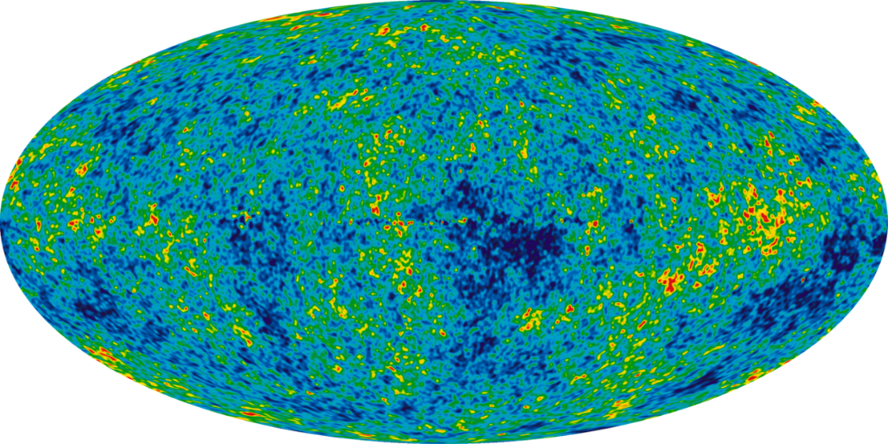

#### The Hubble Constant and Spatial Expansion

Alexander Friedmann was the first to show that solutions to Einstein’s field equations had possible solutions for both an expanding and contracting universe. Einstein did not readily accept this idea but with empirical evidence, eventually admitted that Friedmann was correct (after Friedmann had died from typhoid).

Georges Lemaitre found a similar solution and used empirical astronomical data to show that the universe was expanding. Due to the fact that all points in space are expanding away from each other, objects which are further away move away at a faster speed (since there is more points in space moving away from each other). Using the solution that the universe is expanding at a constant rate, Lemaitre concluded that $\frac{v}{D}=constant$.

Hubble was able to later use empirical evidence to show this relationship and measure the constant. We now call this relationship Hubble’s Law $\frac{v}{D}=H_{0}$ where $H_{0}$ is Hubble’s constant.

In reality the Hubble constant changes with distance, showing an accelerating speed of expansion.

#### Proof for Spatial Expansion

The evidence for this expansion is the emission spectra of stars, where spectral lines of similar stars are shifted, and the further the star is, the more it is shifted.

##### Absorption Spectra as described by Atomic Theory

The absorption spectrum of a star is given by the gaseous particles in its atmosphere. Photons which are emitted by the star that can be absorbed by atoms in the atmosphere are absorbed by those atoms, the re-emitted later with a random direction. The result of this is that a much lower intensity of the light reaches the earth.

#### Accelerating Spatial Expansion

It was believed that the most probable solution to Einstein’s field equations was that space may be expanding, but that it was slowing down due to the negative potential energy of gravity. It turns out that it is possible (and allowed in the field equations) for the universe to have a positive energy content which would cause the universe to expand at an accelerating rate. This energy can be measured by making this assumption but is not directly predicted by any current theories.

The accelerating rate of spatial expansion was measured by a physicist at ANU. What they found was that the Hubble constant for distant supernovae increased the further away you look, showing that the velocity at which objects move away from each other changes with time and with a positive gradient (i.e. $\frac{∆v}{∆t}>0$).

For more, you can watch the video from the man himself: <https://www.youtube.com/watch?v=55pcpTjd3BY&ab_channel=ANUTV>

The mechanism for this expansion is called Dark Energy, though nothing is known about it.

##### The Hertzsprung-Russel (H-R) diagram

The colour, size and mass of a star can be associated with its temperature and luminosity.

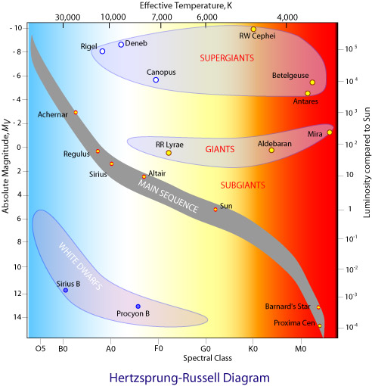

Source: CSIRO

###### The Axes

* **Absolute Magnitude**: How bright the star would appear if it were 10 parsecs away (on a logarithmic scale)
* **Luminosity**: The power output of the star
* **Temperature**: The surface temperature of the star which causes blackbody radiation
* **Spectral Class**: The colour of the star defined at certain cut-off points.

High Mass stars are typically towards the top of the diagram since high mass stars can fuse more atoms per second and therefore are more luminous.

All stars emit light as a function of blackbody radiation (where the wavelength emitted depends on their surface temperature).

The red giants are giant because they are fusing lots of atoms producing a large outward pressure. However, the energy produced is spread across many layers, so the outer layer is cooler and therefore more red.

White dwarfs are the remains of the cores of stars which emit light due to blackbody radiation but no longer fuse nuclei. They have been compressed to the point where the only thing keeping them at a fixed radius is the outwards pressure of the electrons in their shells. The Pauli Exclusion Principle keeps them from compressing further so they maintain their size.

Neutron stars are white dwarfs where the gravity was so strong it allowed the electron shells to shrink and the electrons to combine with protons to make neutrons. Now the only thing keeping them apart is the pressure of the exclusion principle between the neutrons.

### The formula not on the sheet

One of the only formulae mentioned in NESA example questions not in the syllabus is the formula for the luminosity of a star (black body).

This is the Stefan-Boltzmann Law and is given by the equation:

$$L=σA_{s}T^{4}, σ=5.7×{10}^{-8} W m^{-2} T^{-4}$$

Where $L$ is luminosity, $A_{s}$ the surface area of the star and $T$ the surface temperature in Kelvin.

## From the Universe to the Atom Questions

### Question 1

Describe the experimental setup Chadwick used to discover the neutron. Include relevant diagrams.

### Answer 1

Chadwick used alpha particles to eject an unknown particle from Beryllium. This particle then collided with Paraffin wax, causing a proton to be ejected (which can be detected due to its charge).

When a charge detector was placed between the beryllium and the wax it did not detect anything, confirming the alpha particles were not getting through.

When the detector was placed after the wax, a charged particle (eventually calculated to be a proton) was detected.

By placing a lead block in between the beryllium and the wax the emission of protons was stopped, confirming that a particle was being emitted from the beryllium.

Using conservation of momentum Chadwick determined that this neutral particle had a mass very similar to a proton and reasoned that it must be the theoretically predicted neutron.

$$α$$

$$Be$$

$$Wax$$

$$Charge \\ Detector$$

$$Pb$$

$$Nuetron$$

$$Proton$$

### Question 2

Describe the historical progression of the model of the atom, refer to all key models and the experiments which led to their development.

### Answer 2

Dalton was the first to publish a formal theory of the atom, and he believed each atom was its own type of ‘billiard ball’.

Thompson used cathode rays to show that all metal atoms appeared to contain the same negatively charged particle. He did this by using electric and magnetic fields to measure the charge : mass ratio of the ejected particle and showed it was the same for all of the materials. From this he created the ‘plum-pudding’ model where the atom is a positively charged ‘billiard ball’ with negative electrons dispersed throughout.

Geiger and Marsden used alpha particles and fired them at a very thing sheet of gold foil. Surprising to them was that most of the particles passed through undeflected, with only a small fraction being deflected. However, these deflected particles showed large angles of deflection, with many having a reflection angle $θ>90°$.  
From this Rutherford developed the planetary model where the nucleus is very dense and positively charged, with the light electrons orbiting in the empty space around it. This, however, failed to explain how electrons orbit, since the accelerating electrons should be constantly losing energy as light, in a continuous spectra.

Bohr used the known discrete spectra of atoms to develop a theory of the atom where electrons orbit at fixed radii, with $mvr=\frac{nh}{2π}=nℏ$. This model provided a logical explanation for atomic spectra (which was found through experiment) though it failed to explain why its conditions were true.

deBroglie took Einstein’s idea of light being both a particle and a wave (which he concluded from his experimentation with the photoelectric effect) and applied the idea to electrons. deBroglie was able to show that if the electron were a standing wave wrapped around the nucleus, it must have fixed orbits for the wave shape to be continuous (i.e. have an integer number of wavelengths wrapped around the diameter).

The evidence for single electrons diffracting and interfering with themselves when passing through a double slit provided evidence for the wave model of the electron and allowed Schrodinger to develop his probability model of the atom, where there is a dense nucleus of protons and neutrons with a ‘cloud’ of electrons around it. The electron itself is a probability wave, with its position at any time being somewhere within the 3D cloud, which itself represents the wave function.

### Question 3

Outline the properties of a proton; its constituent parts; and the resulting interactions that the proton can partake in.

### Answer 3

A proton is made of three quarks:

$$U$$

$$U$$

$$D$$

Quarks have electric charge and can therefore interact via the electromagnetic force. This force is mediated by the exchange of photons.

Quarks have colour charge and can therefore interact via the strong force. This force is mediated by the exchange of gluons.  
As a result of this, protons can also trade quarks with other protons or neutrons through the *nuclear interaction*. This creates an attractive force about 100x stronger than the electromagnetic repulsion between protons inside the nucleus.

Quarks can also interact via the weak force which results in a change in charge and flavour of the quarks withing the proton. This will most commonly cause a proton to transmute into a neutron. This force is mediated by the $W^{+}$, $W^{-}$ and $z^{0}$ bosons.

Last of all, quarks and the gluon fields between them have energy (and therefore mass). This allows the proton to participate in gravitational attraction.

### Question 4

Explain FOUR requirements necessary for a controlled fission chain reaction of Uranium-235 to be sustained

### Answer 4

1. Enrichment
   * Enrichment is the process of increasing the proportion of desired atoms within the reaction vessel, thus increasing the chance of a favourable reaction and collision between an ejected neutron and another U-235 atom.
2. Moderator
   * The moderator is a material rich in nuclei that have slightly larger masses than neutrons. The moderator decreases the kinetic energy of the neutrons ejected by U-235 atoms so that the neutrons have a higher probability of being absorbed into another U-235 atom.
3. Reactor Vessel
   * The reactor vessel is the container in which the fission reaction takes place. There is a requirement for the vessel to have a particular surface area – volume ratio for an ideal reaction rate and the interior surface often has a high nucleon number material to readily reflect neutrons back into the vessel. (Such as Boron or Cadmium)
4. Control Rods
   * Control rods are a material that absorbs neutrons, which decreases the rate of reaction when inserted, thus controlling the reaction. The rods are used to prevent a ‘runaway reaction’ and to keep the rate of reaction stable.

### Question 5

Carbon-14 $\left({}_{6}^{14}C\right)$ decays via $β$ decay into Nitrogen-14 $\left({}_{7}^{14}N\right)$ with a half-life of $5730$ years.   
During this decay process there is an associated mass defect of $Δm=-8.722×{10}^{-32} kg$ per reaction. Carbon-14 has an atomic mass of $14.003 u$.

Calculate the mass of a $5.000 g$ sample after 10 years and calculate the associated energy released over that time.

### Answer 5

The half life equation is generally applicable to any quantity, so we can merely substitute number of atoms for mass:

$$m_{t}=m_{0}e^{-λt}$$

$$λ=\frac{\ln{2}}{5730 yrs}$$

$$t=10 yrs$$

$$m_{t}=5 g⋅e^{-\frac{10⋅ln{2}}{5730}}$$

$$m_{t}=4.994 g$$

Now the tricky thing is that we don’t yet know how much mass defect we have (because most of the mass is preserved in the products).

We know that one atom has an average weight of $14.003 u$ or $2.326×{10}^{-26} kg$

With a mass of $Δm=0.006 g$ of Carbon-14 that has decayed this gives us

$$N_{decay}=\frac{{0.006×10}^{-3}kg}{2.326×{10}^{-26} kg}=2.5795×{10}^{23} atoms$$

Now we have the number of decays we can find the amount of mass defect in total by multiplying.

$$Δm_{defect}=-8.722×{10}^{-32} kg⋅2.5795×{10}^{23}=-2.249×{10}^{-8} kg$$

$$E=mc^{2}$$

$$E_{released}=2.025×{10}^{9} J$$

### Question 6

Calculate the minimum energy required by a photon to ionize hydrogen with an electron in a stable state in the first orbital.

### Answer 6

“Ionize” means to knock an electron to an infinite orbital (i.e. $n_{f}=∞$).

The energy of the photon is given by this term (it will be useful in a moment).

$$c=fλ$$

$$E=hf=\frac{hc}{λ}$$

$$\frac{1}{λ}=R\left(\frac{1}{n_{f}^{2}}-\frac{1}{n_{i}^{2}}\right)=R\left(\frac{1}{∞}-\frac{1}{1}\right)=R$$

Now we substitute from earlier:

$$E=hcR$$

$$E=2.2×{10}^{-18} J$$

*It is worth noting that many questions ask for frequency not energy, however this is easy since $E=hf$, so simply dividing by $h$ gives $f=cR$*

### Question 7

With reference to the axes of the H-R diagram, describe the different aspects of a star and how they affect their position on the diagram.

### Answer 7

There are two main axes on the H-R diagram: absolute brightness (luminosity) and temperature (which gives a star its colour before Doppler shift).

The luminosity of a star is affected by its temperature and its surface area by the Stefan-Boltzmann Law $L=σA_{s}T^{4}$. The luminosity is independent of the brightness observed on Earth as it describes the total energy output of the star via radiation (though in reality this requires work to calculate).  
If a star has a strong gravitational pull, then it will try to hold itself in a smaller volume, however the outward pressure due to its temperature resists this and they reach an equilibrium. Because of how the factors work out, the changes in temperature are much more dominant than those of size so very massive stars will tend to be much brighter, even if they are smaller.

The temperature is directly effected by the rate of reactions within the star producing energy (fusion). The rate of reaction releases energy in the form of energetic particles including photons. However these photons are not what is seen as the colour associated with the temperature. Instead, the released particles heat up the gasses of the star and these gasses then radiate vie black body radiation, obeying Wein’s Law ($λ_{max}=\frac{b}{T}$).

What is interesting is that the two axes are actually strongly linked, with the rate of internal reaction and the gravitational strength (which is also tied to this) affecting these factors. For the sake of simplicity, they have been considered separately, however the underlying physics is much more nuanced and explains why stars of specific sizes and ages tend to group in the same luminosity-temperature areas.

# Smarter Study

## Top Tips

Studying for Physics is somewhat different to other subjects. It relies much more heavily on you actually understanding the concepts rather than being able to recite ideas, second only in that regard to Maths.

As a result, the way you should study for Physics is more based on being able to explain concepts or do the working for an algebraic answer.

### Link Concepts to Formulae

Physics provides a rather generous formula sheet, and for every formula on there, there’s a related concept. So, instead of trying to remember concepts and the formulas which belong to them, use the formula to remember the concept.   
For instance, the change in flux formula:

$$ε=-\frac{Δϕ_{B}}{Δt}$$

Instead of memorising that a ‘a changing magnetic flux causes an electric field…’ instead use the formula to remember it. It’s all there, even the negative sign can be used to remember that the field opposes the one producing it.

The best way to practically apply this is also to make the formula sheet your notes, writing concepts next to the equations and seeing if you can explain the concept using the equation.

### Understand the Maths

Physics is different to most HSC subjects in that it requires you to interpret the maths. The top achievers aren’t just able to remember the formulae, they can also tell you why the parts of the equations are important.

For example, the fact that momentum is linearly related to speed $\left(p=mv\right)$ but kinetic energy is proportional to the speed squared $\left(E_{K}=\frac{1}{2}mv^{2}\right)$ means that there are situations where kinetic energy can be conserved but momentum isn’t or vice versa.

## Exam Tips

Physics is a bit different to most other subjects because it has a different way that it marks. What Physics is actually testing you on is two things:

* Do you understand what you’re doing / saying?
* Can you do algebra?

If you succeed at both of these then you’re probably pretty solidly going for a band 6. If you’re lacking in either of these, then you might be struggling a little more. In reality, a lot of people understand the concepts but get caught out by silly mistakes or by calculator errors.

There is no substitute for a genuine understanding of a concept, but here are my best tips / tricks to minimise your mistakes and get the best mark possible.

### Maths Questions: Do the algebra

Let’s say you get given the following question: What is the velocity of a ball which fell 5 metres under gravity?

There are multiple ways to do this question but here we’re going to use:

$$ΔE_{K}=-mgΔh$$

$$\frac{1}{2}mv^{2}-\frac{1}{2}mu^{2}=-mgΔh$$

Now at this point is when most people would substitute values, (i.e. $Δh=-5$, $g=9.8$ etc.) **but**, I would argue not to do that, instead you should keep rearranging until you get an equation for $v$.

$$\frac{1}{2}mv^{2}=-mgΔh$$

$$\frac{1}{2}v^{2}=-gΔh$$

$$v=\sqrt{-2gΔh}$$

Why would you do this? Well, it’s easy to accidentally forget a random 2, but it’s hard to forget $g$. In that sense it’s harder to make mistakes this way. Also, if you make a calculator error now, the rest of your answer is still correct so you at most lose 1 mark. If you had made a mistake before, you *might* get error carried forward.

Now obviously we can substitute values:

$$v=\sqrt{-2×9.8×-5}=\sqrt{98}$$

### Maths Questions: You don’t have to simplify

Ok so I was just saying how it’s best to do more algebra, but now I’m saying do less? Well, no.

Let’s say you do your algebra for a question and arrive at

$$t=\frac{-u±\sqrt{u^{2}-4ah}}{a}$$

Now, if $a= -10 m s^{-2}, u=5 m s^{-1}, h=5 m$, you might be tempted to just jump in and simplify. But then you run the risk of making a mistake.

The answer above is correct (well one of them is), so most of the time you don’t need to simplify like in maths. Physics doesn’t care how simple it is, only if it’s correct. So **put it in your calculator**. That’s it, once you find a solution just plug it right into you calculator and you’ll make less mistakes.

The only case in which this isn’t true is if you are specifically asked to fully simplify.

### Written Questions: Dot points

Almost every marker will genuinely love you for doing dot points. Dot points are clear, easy to read and easy to mark. The only downside is maybe they take up more space, but that’s what extra writing paper is for.

Provided your dot points are still coherent sentences, they are strongly recommended by many HSC markers.

### Written Questions: Everything is a process

Asking ‘why?’ is at the core of physics. So, it makes sense that if you don’t properly answer the marker’s ‘why?’ then you won’t get the marks.

Another way of thinking about it is that there is always something, which causes something else, which then causes something else. If you miss any of these, then your answer becomes confusing.

Take this example response from a physic student to the question:  
What happens as a magnet with field strength $B$ passes over a conductive loop of Area $A$?   
(Just to be clear this is not a top response)

1. The changing magnetic field produces a changing magnetic flux though the loop.
2. The changing magnetic flux produces an EMF inside the loop.

This is not a good response because I’m left asking “but why is there a changing magnetic field? I thought the magnet’s magnetic field is constant.”

A better answer would have said:

1. The magnet’s magnetic field produces a magnetic flux through the loop.
2. As the magnet moves the strength of the magnetic field through the loop changes, producing a changing magnetic flux with time.
3. The changing magnetic flux produces and EMF in the loop.

This answer is better because it isn’t missing any logical steps.

A good trick to try when practicing is every time you say that something happens (e.g. a current is induced in the loop), ask yourself “why?”. If your previous statement does not answer that question then you have missed something.

## Most Tested Concepts

### Advanced Mechanics

|  |  |
| --- | --- |
| Concept | Examples of Question Topics |
| Projectile Motion | * Solve for the time of flight * Solve to the highest point * Solve for the final velocity |
| Circular Motion | * Solve for the tension in a string when an attached mass is undergoing circular motion * Solve for the normal force on a banked curve |
| Conservation of Energy | * Solve for the change in total energy of a satellite as it moves from one orbit to another * Find the final kinetic energy of a falling object |

### Electromagnetism

|  |  |
| --- | --- |
| Concept | Examples of Question Topics |
| Faraday-Lenz Law | * Explain how eddy currents are induced * Calculate the average emf in a motor * EMF induced in a coil moving through a magnetic field * EMF induced in a coil inside a changing magnetic field |
| Projectile Motion | * Motion of charged particles in a uniform electric field |
| Motor Effect | * Force on a charged particle moving in a magnetic field and the resultant motion * Force on a wire in a magnetic field * Forces on parallel wires |

### The Nature of Light

|  |  |
| --- | --- |
| Concept | Examples of Question Topics |
| Models of Light | * Describe the timeline of the development of the model of light and provide reasons for the changes * Describe the contributions of different scientists (e.g., Maxwell) to the model of light |
| Emission Spectra | * Describe how the emission spectra of a star can be used to infer its properties |
| Black Body Emission Curve | * Analyse qualitatively and quantitatively the intensity-wavelength curve of a black body |

### From the Universe to the Atom

|  |  |
| --- | --- |
| Concept | Examples of Question Topics |
| Standard Model | * Describe the different particles associated with the standard model |
| Mass Defect | * Describe the mechanism for the change in mass in chemical and nuclear reactions * Describe quantitatively the energy associated with a mass defect |
| HR Diagram | * Use the HR diagram to describe the properties of a star |

## Common Questions

**Can I just memorise all the stuff from the syllabus and ‘tick off the dot points’ to be good for the exam?**

Sort of, it depends on your definition of good. If you want to get a 60% – 75% then yes, if you know the answer to every syllabus dot point you can get a mark in this range.

But, to get more marks you have to be able to connect the dots 😉. The syllabus is structured in a way that each of the modules require some background knowledge from the previous module, so figure out what that is and then you will be much better equipped. For instance, a top student can apply concepts learned in mechanics to almost every area of physics.

**What’s the best way to study?**

Again, that sort of depends on who you are. Whether you find making notes or watching YouTube videos most effective is purely personal preference. But two things which I found useful were

1. I did lots of practice questions (at least 10 a week as we started new topics)
2. I played around with the maths and figured out why different parts of equations meant different things.

**Does my maths ability matter?**

This is sort of a harsh reality but yes. If you are doing maths standard or have dropped it all together then there will be aspects of the maths of this course that are hard. Luckily, most of the maths required is rearranging equations, a skill which is taught in Year 9 & 10 and a skill definitely worth brushing up on.

1. This example is not exactly accurate to reality as the space station is undergoing centripetal acceleration and is therefore in a non-inertial reference frame (i.e. we need general relativity to describe the situation). However, this example should otherwise provide a plausible situation where an object is moving at a relatively fast speed.
2. The experiment actually resulted in a speed up of the clocks on the plane which is predicted by General Relativity, since they were further away from the Earth and therefore further out of its gravitational space-time well. However, since General Relativity includes special relativity, it confirms both. (This is not necessary to mention for marks, merely for the sake of correctness).